**Ludlum 2000 Assembly Procedure**

**Project Explanation**

**Version 00.1**

Revision History

|  |  |  |  |
| --- | --- | --- | --- |
| **Date** | **Version** | **Description** | **Author** |
| 2016JN15 | 00.1 | Draft | [Auteur ] |
|  |  |  |  |
|  |  |  |  |
|  |  |  |  |
|  |  |  |  |
|  |  |  |  |
|  |  |  |  |

**Table of contents**

**1.** **Introduction** 7

**1.1** **Electrical Safety and general warning** 7

**1.2** **Purpose** 7

**1.3** **Scope** 7

**1.4.** **Project identification** 8

**1.5.** **Project requirement** 9

**2.** **Ludlum 2000 rate Meter Mechanical Preparation** 10

**3.** **Ludlum 2000 Rate Meter Preparation** 11

**3.1.** **Ludlum 2000 Rate Meter Metal Case Left Side and Top Side** 11

**4.** **Ludlum 2000 Rate Meter Battery Holder Removal** 13

**4.1.** **Ludlum 2000 Rate Meter Battery Holder** 14

**4.2.** **Ludlum 2000 rate Meter Back Encloser** 16

**4.3.** **Ludlum 2000 rate Meter Bottom Encloser** 17

**4.4.** **Ludlum 2000 Rate Mete Battery Holder** 17

**5.** **Ludlum 2000 Rate Meter Metal Enclosure Preparation** 18

**5.1.** **Ludlum 2000 Rate Meter IEC Power Inlet C13 Preparation** 21

**5.2.** **Ludlum 2000 Rate Meter Fuse Holder Preparation** 21

**5.3.** **Ludlum 2000 Rate Meter Metal Case Separation** 21

**5.4.** Ludlum 2000 Rate Meter Metal Case 22

**5.5.** Ludlum 2000 Rate Meter Ethernet Module Holding Bracket 22

**5.6.** Ludlum 2000 Ethernet Jack Holding Bracket Installation 23

**5.7.** Ludlum 2000 Ethernet Metal Plate Installation 24

**6.** **Ludlum 2000 Rate Meter PCB Holding Bracket Preparation** 25

**7.** **Ludlum 2000 Rate Meter Electrical Preparation** 26

**8.** **Ludlum 2000 Rate Meter Power Supply Board Preparation** 27

**8.1.** Ludlum 2000 Rate Meter Power Supply Board Preparation 28

**9.** **Ludlum 2000 Rate Meter Electrical Wiring (DC Power)** 30

**9.1.** Ludlum 2000 Rate Meter Wire Loom Electrical wire harness preparation 34

**9.2.** Ludlum 2000 Rate Meter DC Input Supply Preparation 37

**9.3.** Control Switch Ludlum 2000 Rate Meter 38

**9.4.** GND Terminal Ludlum 2000 Rate Meter 39

**9.5.** Ludlum 2000 Rate Meter Wire Loom completion 40

**10.** **Ludlum 2000 Rate Meter Power Input Jack Installation** 41

**10.1.** Ludlum 2000 Rate Meter Power Input Jack Installation 42

**11.** **Ludlum 2000 Rate Meter Data Cable Preparation** 43

**11.1.** **Ludlum 2000 Rate Meter "Data Connector" Control Signal** 45

**11.2.** **Ludlum 2000 Rate Meter "Data Connector" Data Output** 47

**11.3.** **Ludlum 2000 Rate Meter to Interface Connector (Control Signal)** 48

**11.4.** **Ludlum 2000 Rate Meter to Interface Connector (Data Output)** 50

**11.5.** **Ludlum 2000 Rate Meter Interface Connector** 50

**12.** **Ludlum 2000 Rate Meter Ethernet Module Installation** 52

**12.1.** **Ludlum 2000 Rate Meter Ethernet Module Installation** 53

**13.** **Ludlum 2000 Rate Meter Final Installation** 55

**14.** **Ludlum 2000 Rate Meter Telnet Server** 58

**14.1.** **Ludlum 2000 Telnet Server Welcome Page** 59

**14.2.** **Ludlum 2000 Telnet Server Commands Page** 60

**14.3.** **Ludlum 2000 Rate Meter Telnet Server: List Of Available Function** 61

**14.4.** **Telnet Server: DO Commands Page** 62

**14.5.** **Ludlum 2000 Rate Meter Telnet Server: Command DO Page** 62

**14.6.** **Ludlum 2000 Telnet Server SC Commands Page** 63

**14.7.** **Ludlum 2000 Telnet Server SC Command Page** 63

**14.8.** **Ludlum 2000 Telnet Server CL Commands Page** 64

**14.9.** **Ludlum 2000 Telnet Server CL Commands** 64

**14.10.** **Ludlum 2000 Telnet Server ? Commands Page** 65

**14.11.** **Ludlum 2000 Telnet Server ? Commands** 65

**15.** **Microcontroller Boot Loader Installation** 66

**15.1.** **ArduinoTM Programming Environment Preparation** 67

**15.2.** **ArduinoTM programming environment overview** 69

**15.3.** **Arduino Bootloader Programming Sketch Preparation** 70

**15.4.** **Arduino Bootloader (Atmega 1284 Microcontroller) Cross talk Issue** 70

**15.5.** Ludlum 2000 Rate Meter PCB Board Electrical Connection 72

(Boot Loader Installation) 72

**16.** **Ludlum 2000 Rate Meter PCB Board (Programme Upload)** 75

**16.1.** **Microcontroller Selection** 76

**16.2.** **Programming Port Allocation** 77

**16.3.** **Ludlum 2000 Rate Meter Program files** 78

**17.** **Ludlum 2000 Rate meter specification** 80

Table of figure

Figure 1: Ludlum 2000 Rate Meter Metal Case 10

Figure 2: Ludlum 2000 Rate Meter Metal Case Top side 11

Figure 3: Ludlum 2000 Rate Meter Battery Holder 14

Figure 4: Ludlum 2000 Rate Meter Back Enclosure 15

Figure 5: Ludlum 2000 Rate Meter Bottom Encloser 16

Figure 6: Ludlum 2000 Rate Meter Battery Holder 16

Figure 9: Ludlum 2000 Rate Meter Interface PCB (Supply Voltage) 27

Figure 10: Ludlum 2000 Rate Meter IEC Inlet Module Preparation. 28

Figure 7: Ludlum 2000 Rate Meter to Interface Connector (Control Signal) 39

Figure 8: Ludlum 2000 Rate Meter Interface Connector (Data Output) 40

Figure 11: Ludlum 2000 Telnet Server Welcome 48

Figure 12: Ludlum 2000 Commands Page 49

Figure 13: Ludlum 2000 Telnet Server: Command DO 51

Figure 14: Ludlum 2000 Telnet Server SC commands Page 52

Figure 15: Ludlum 2000 Telnet Server RM commands Page 53

Figure 16: Ludlum 2000 Telnet Server CL commands 54

Figure 16: Ludlum 2000 Telnet Server CL commands 55

Figure 11 : ArduinoTM programming environment overview 59

Figure 12: Microcontroller Selection 66

Figure 13: Programming Port Allocation 67

Figure 14: Ludlum 2000 Rate Meter Program files 68

Figure 15: ArduinoTM programming environment Compilation 69

## **Introduction**

### **Electrical Safety and general warning**

The voltages used in the electrical panel can cause severe electrical shock and/or burns

Inspection must be carried by personnel who have the necessary training and experience with electrical code and procedure implemented at Draximage. Electronic technician or engineer part of Software and electronic development team should carry the final inspection of the control panel.

### **Purpose**

Install a microcontroller and supportive hardware inside the Ludlum 2000 rate Meter.The microcontroller will allow the Ludlum 2000 Rate Meter to be connected on the office Ethernet network and communicate with a remote server. The Ludlum 2000 Rate Meter will measure the level of radioactive background present in the vicinity of the probe.

### **Scope**

This document is part of the validation and certification of the Ludlum 2000 Rate Meter. The commissioning process will ensure that all the electrical and electronic system are installed tested and operated according to Draximage electrical standard and guideline document. This document must allow the persons in charge of the project to make sure that all the system is conform to the user requirement document.

### **Project identification**

|  |  |  |  |  |  |
| --- | --- | --- | --- | --- | --- |
| **Name of the Document** | **Date / revision number of the document** | **Created or Available** | **Received or Reviewed** | **Author or Resource** | **Notes** |
| Electrical schematics  Ludlum 2000 Rate Meter | 2016JN15/0.1 | 🞏Yes ■ No | ■ Yes 🞏 No | Abel Ouellette |  |
| Electrical PCB Layout  Ludlum 2000 Rate Meter | 2016JN15/0.1 | 🞏Yes ■ No | ■ Yes 🞏 No | Abel Ouellette |  |

Figure 1 : Project identification

### **Project requirement**

The Ludlum 2000 Rate Meter modification project includes the following requirement:

* Installation of the PCB with microcontroller inside the Ludlum 2000 Rate Meter enclosure.
* Installation of Ethernet module inside the Ludlum 2000 Rate Meter enclosure.
* Installation of a dedicated power supply for the microcontroller and Ethernet module.
* Installation of supportive hardware.
* PCB Board Assembly and Programming
* Telnet Server Test

## **Ludlum 2000 rate Meter Mechanical Preparation**

* Battery Holder Removal
* Ludlum 2000 Rate Meter Metal Enclosure Preparation
* Ludlum 2000 Rate Meter Metal Enclosure Device Installation

## **Ludlum 2000 Rate Meter Preparation**

|  |  |  |
| --- | --- | --- |
| Ludlum 2000 Rate Meter Preparation | | |
| Procedure | Test Result | Technician (Initial for conformity) |
| Ludlum Rate Meter Preparation | | |
| Remove the 3 screws on each side and two screws on the top then remove the metal case to expose the Ludlum 2000 Rate Meter inner circuit board.  Open the Ludlum 2000 Rate Meter Case.  Note: Keep all screw from the Ludlum rate meter metal case for reassembly | 🞏 Pass  🞏 Fail |  |

Table 2: Ludlum 2000 Rate Meter Preparation

### **Ludlum 2000 Rate Meter Metal Case Left Side and Top Side**

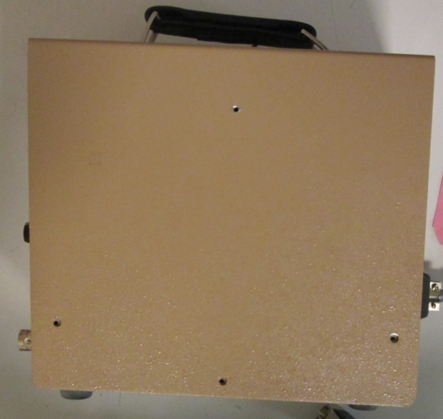

Figure 1: Ludlum 2000 Rate Meter Metal Case

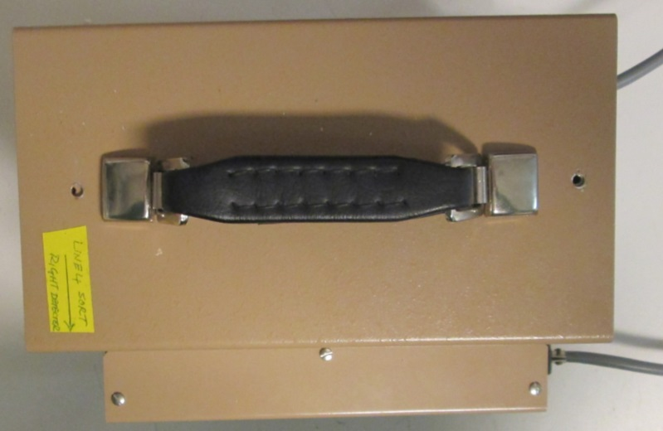

Figure 2: Ludlum 2000 Rate Meter Metal Case Top side

## **Ludlum 2000 Rate Meter Battery Holder Removal**

|  |  |  |
| --- | --- | --- |
| Ludlum 2000 Rate Meter Battery Holder Removal | | |
| Procedure | Test Result | Technician (Initial for conformity) |
| Ludlum 2000 Rate Meter Preparation  Battery Holder Removal & Expansion Card Metal Holder Removal | | |
| * Expansion Card   The Ludlum 2000 Rate Meter expansion card is secured with 1 screw.  Remove each screw on each of the Ludlum 2000 Rate Meter expansion card.  The Ludlum 2000 Rate Meter expansion card metal holder is secured with 4 screws.  Remove each screw on the Ludlum 2000 Rate Meter expansion card metal holder.  Note 1: Remove each expansion card (3 expansion card in total)  Note 2: Keep all screw from the Ludlum rate meter expansion card and holder for reassembly. | 🞏 Pass  🞏 Fail |  |
| Ludlum Rate Meter Preparation Battery Holder Removal  Battery Holder Metal Bracket | | |
| The Ludlum 2000 Rate Meter Battery Holder is secured with a metal bracket.  Remove the two screws that hold the battery holder in place. The two screws are located on the button of the Ludlum 2000 Rate Meter encloser. | 🞏 Pass  🞏 Fail |  |
| The Ludlum 2000 Rate Meter Battery Holder  Battery Holder Access Metal Plate and Screw. | | |
| The Ludlum 2000 Rate Meter Battery Access Metal Plate is held in place with four thumb screw.  Remove the four thumb screw to expose the two screws that hold the Ludlum 2000 Rate Meter Battery Holder to the enclosure.  Remove the two screws that hold the Ludlum 2000 Rate Meter Battery Holder to the enclosure.  Pull the Ludlum 2000 Rate Meter Battery Holder from the enclosure.  Note: The Ludlum 2000 Rate Meter Battery Access Metal Plate is used to hold the Ethernet inlet module. | 🞏 Pass  🞏 Fail |  |
| The Ludlum 2000 Rate Meter Battery Holder  Battery Holder Electrical Wire | | |
| Remove the two screws that hold the Ludlum 2000 Rate Meter Battery Holder electrical wire.  Insulate the Ludlum 2000 Rate Meter Battery Holder electrical wire connector with heat shrink tubing. |  |  |

Table 3: Ludlum 2000 Rate Meter Battery Holder Removal

### **Ludlum 2000 Rate Meter Battery Holder**

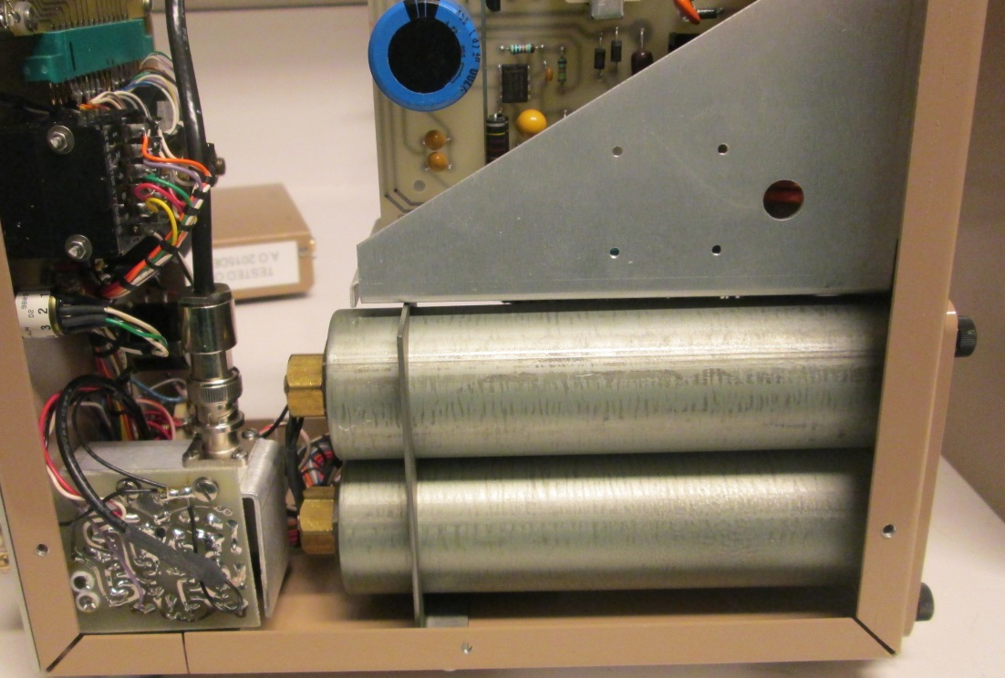

Figure 3: Ludlum 2000 Rate Meter Battery Holder

### **Ludlum 2000 rate Meter Back Encloser**

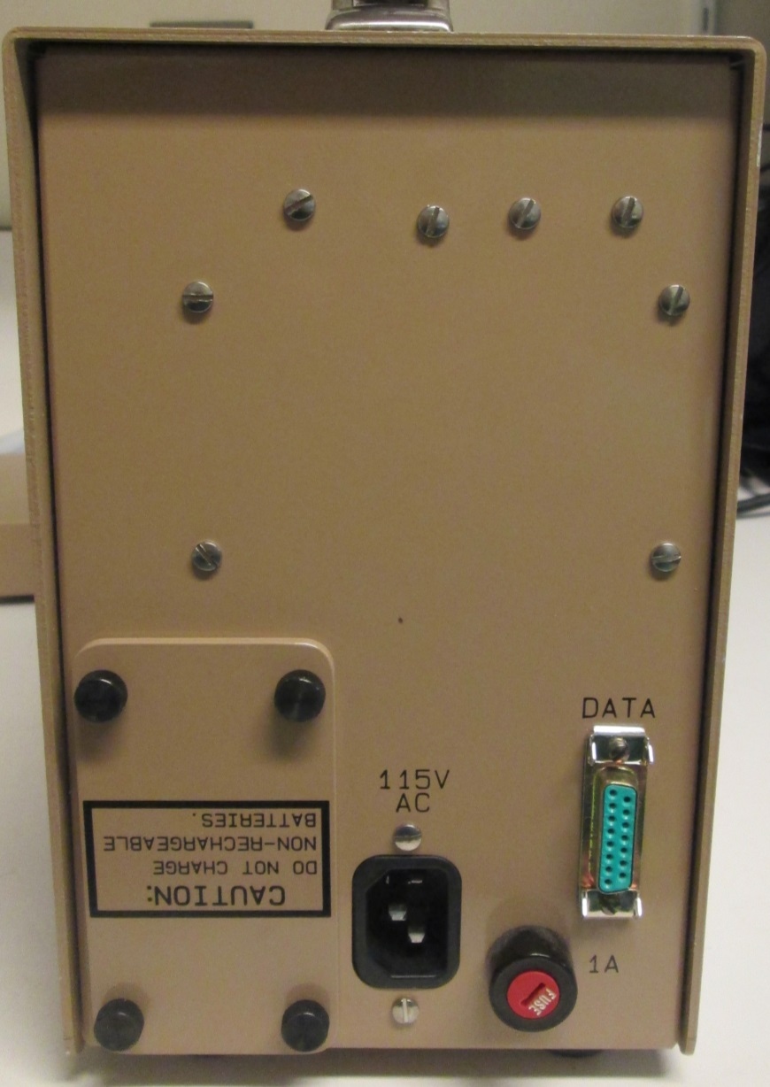

Ludlum 2000 Rate Meter battery holder thumb screw

Ludlum 2000 Rate Meter expansion card holding screw

Ludlum 2000 Rate Meter expansion card metal holder

Figure 4: Ludlum 2000 Rate Meter Back Enclosure

### **Ludlum 2000 rate Meter Bottom Encloser**

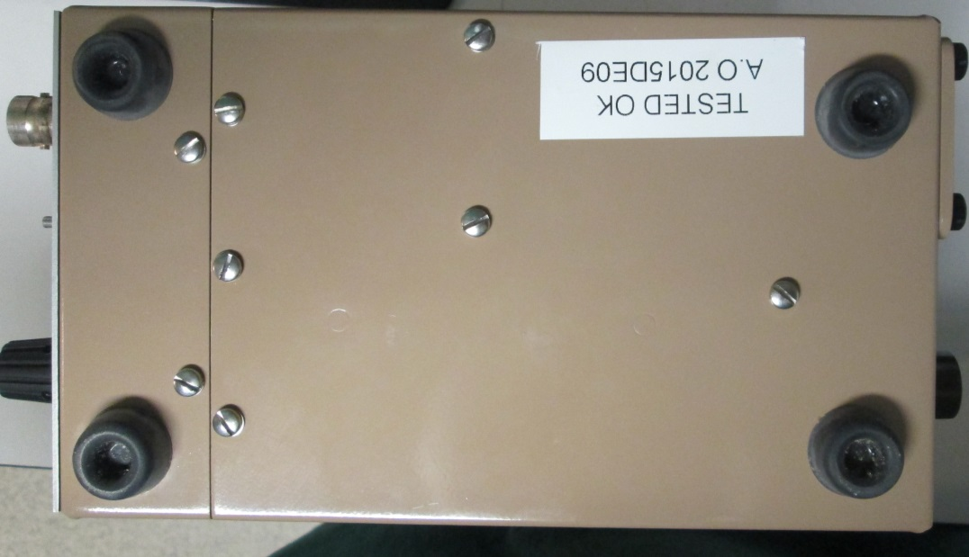

Ludlum 2000 Rate Meter Battery Holder Metal Bracket

Figure 5: Ludlum 2000 Rate Meter Bottom Encloser

### **Ludlum 2000 Rate Mete Battery Holder**

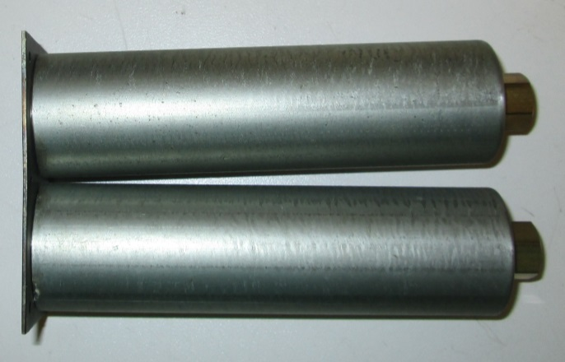

Figure 6: Ludlum 2000 Rate Meter Battery Holder

## **Ludlum 2000 Rate Meter Metal Enclosure Preparation**

|  |  |  |
| --- | --- | --- |
| Ludlum 2000 Rate Meter Metal Enclosure Preparation | | |
| Procedure | Test Result | Technician (Initial for conformity) |
| Ludlum 2000 Rate Meter Preparation Power Inlet Module | | |
| Remove the heat shrink tubing on the metal prong of the Ludlum 2000 Rate Meter IEC Power Inlet module C13.   * Using an electronic welding station, desolder the red and white electrical wire form the metal prong of the IEC Power Inlet module C13. * Using an electronic welding station, desolder the green and yellow electrical wire form the metal prong of the IEC Power Inlet module C13. * Remove the two screw and nuts that hold the Power Inlet Module to the metal frame. * Remove the ground connector from the metal peg located near the IEC Power Inlet module C13.   Note: Red Electrical wire = Line In  White electrical wire = Neutral | 🞏 Pass  🞏 Fail |  |
| Ludlum 2000 Rate Meter Preparation Fuse Holder | | |
| Remove the heat shrink tubing on the metal prong of the Ludlum 2000 Rate Meter Fuse Holder   * Using an electronic welding station, desolder the Red and white/Purple wire from the metal prong of the fuse holder. | 🞏 Pass  🞏 Fail |  |
| The Ludlum 2000 Rate Meter  Power Transformer | | |
| Remove the tow nuts that hold the power transformer. Carefully remove the power transformer form the holding peg. | 🞏 Pass  🞏 Fail |  |
| Remove the heat shrink tubing on the metal prong of the Ludlum 2000 Rate Meter Transformer. The transformer primary side electrical wire are:  White and Blue Electrical wire.   * Using an electronic welding station, desolder the White and Blue wire from the metal prong of the transformer. | 🞏 Pass  🞏 Fail |  |
| Remove the heat shrink tubing on the metal prong of the Ludlum 2000 Rate Meter Transformer. The transformer secondary side electrical wire are:  Orange and Black Electrical wire.  Using an electronic welding station, desolder the Orange and Black electrical wire from the metal prong of the transformer. | 🞏 Pass  🞏 Fail |  |
| The Ludlum 2000 Rate Meter  Power Transformer Mounting Stud Removal | | |
| Remove the holding stud for the Ludlum 2000 Rate Meter Power Transformer.  Use a cold chisel and a hammer. |  |  |
| The Ludlum 2000 Rate Meter  Ethernet Module Holding Bracket | | |
| Drill a hole with an appropriate drill bit to install a holding bracket for the Ethernet module.  Drill the hole that the holding stud for the Ludlum 2000 Rate Meter Power Transformer was used for. |  |  |
| Install the holding bracket for the Ethernet module. Use an 8/32 Cap screw and huts to secure the bracket in place. |  |  |
| The Ludlum 2000 Rate Meter  Ethernet Jack Holding Bracket Installation | | |
| Install the Ethernet Jack on the holding bracket. Secure the Ethernet Jack on the holding bracket with the screw provided with the Ethernet Jack.  The Ethernet Jack Holding Bracket is provided with the appropriate hole and screw pattern. |  |  |
| Install Ethernet Jack Holding Bracket in place.  Use an 8/32 Cap screw and huts to secure the bracket in place. |  |  |
| The Ludlum 2000 Rate Meter  Metal Plate Installation | | |
| Install the metal plate at the back of the Ludlum 2000 Rate Meter to hide the hole left over by the IEC Power Inlet module and the fuse holder.  Secure the metal plate in place with glue and electrical tape. The metal plate come with an appropriate hole for the DC input jack. |  |  |

Table 4: Ludlum 2000 Rate Meter Metal Enclosure Preparation

### **Ludlum 2000 Rate Meter IEC Power Inlet C13 Preparation**

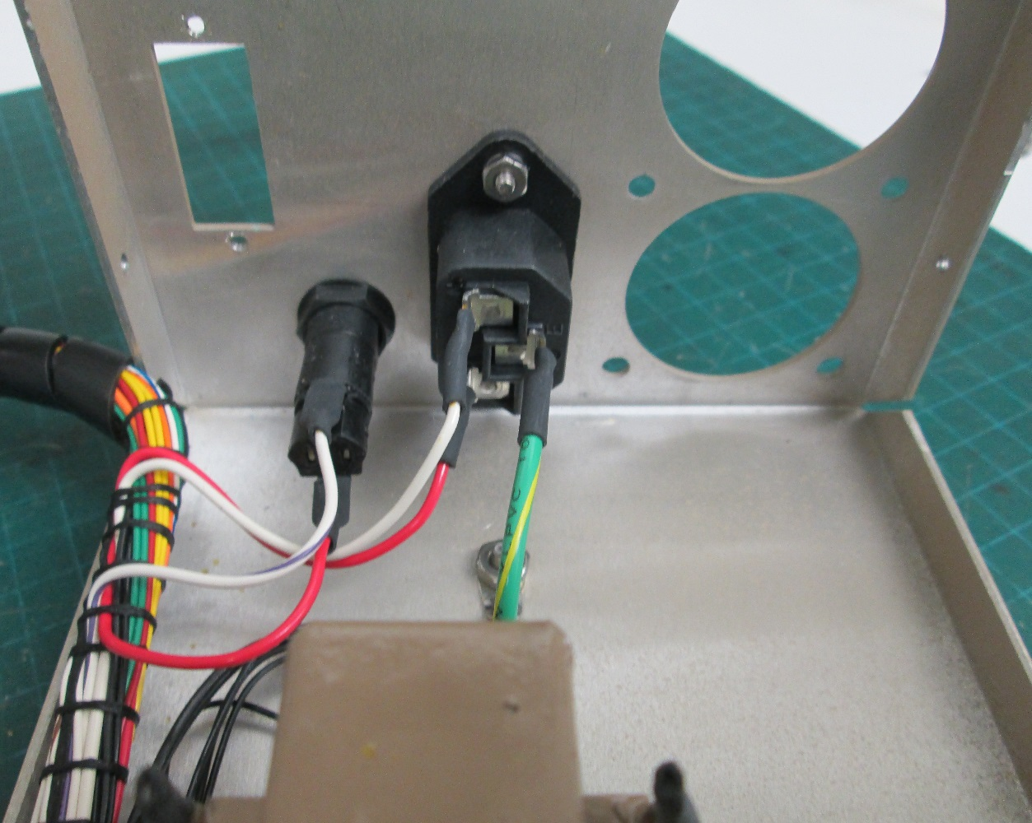

Power Transformer

IEC Power Inlet C13.

Table 5: Ludlum 2000 Rate Meter IEC Power Inlet C13

### **Ludlum 2000 Rate Meter Fuse Holder Preparation**

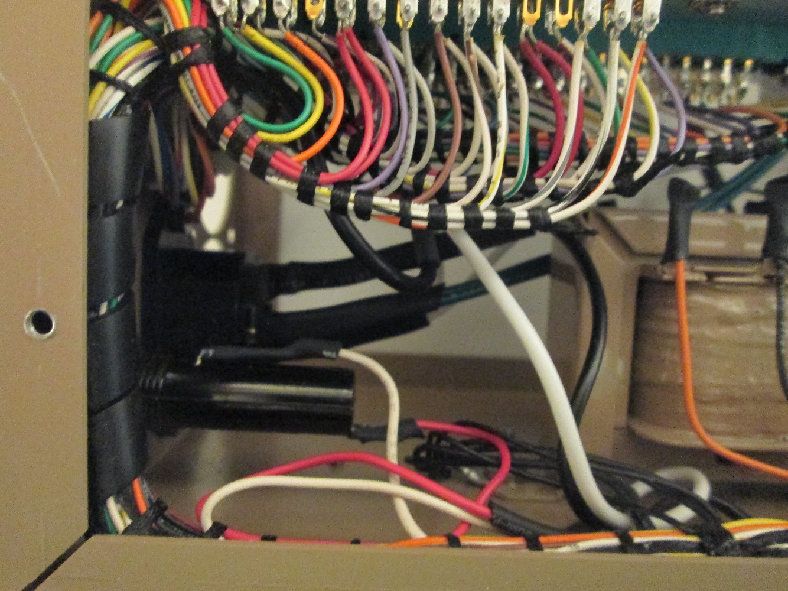

Fuse Holder

Table 6: Ludlum 2000 Rate Meter fuse Holder Preparation

### **Ludlum 2000 Rate Meter Metal Case Separation**

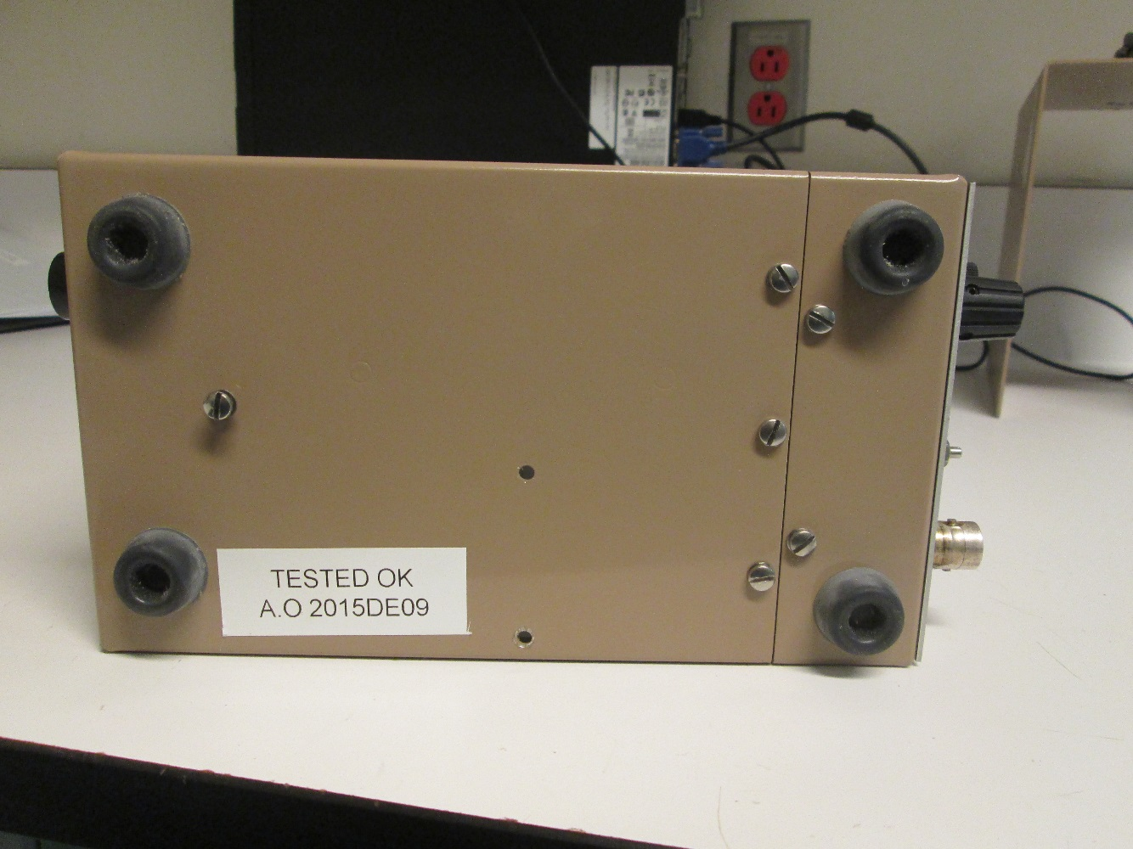

Metal Case Holding Screw

Table 7: Ludlum 2000 Rate Meter Metal Case Separation

### Ludlum 2000 Rate Meter Metal Case

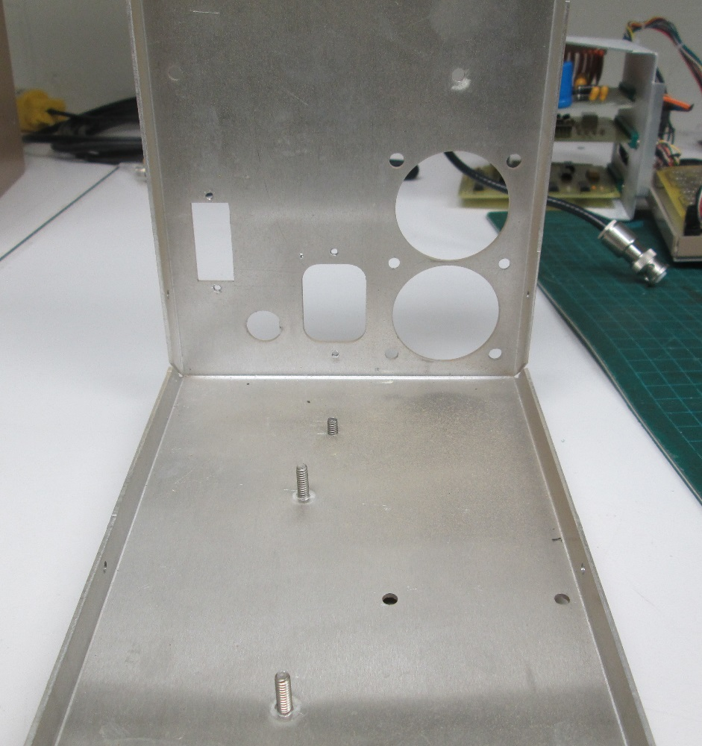

Figure 7: Ludlum 2000 Rate Meter Metal Case

### Ludlum 2000 Rate Meter Ethernet Module Holding Bracket

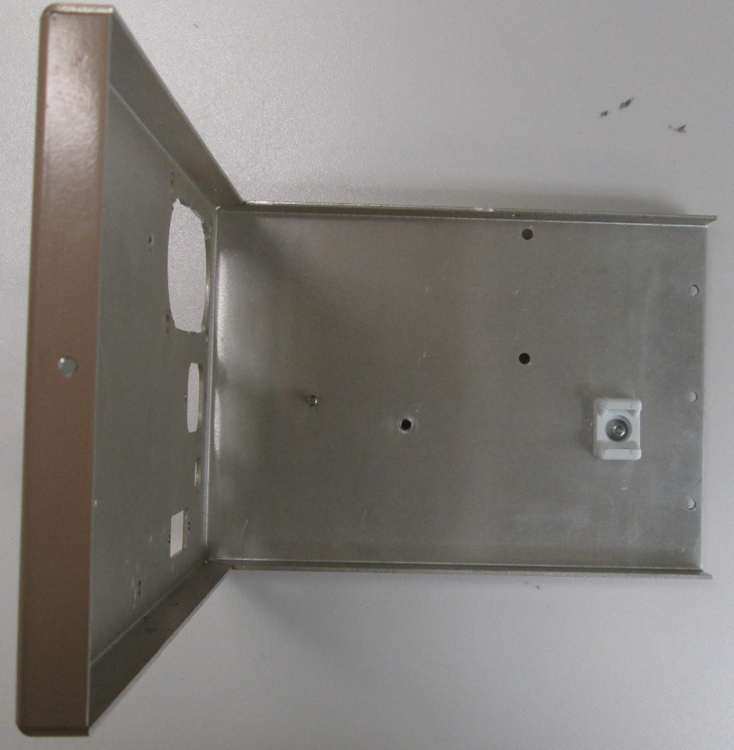

Figure 8: Ludlum 2000 Rate Meter Ethernet

### Ludlum 2000 Ethernet Jack Holding Bracket Installation

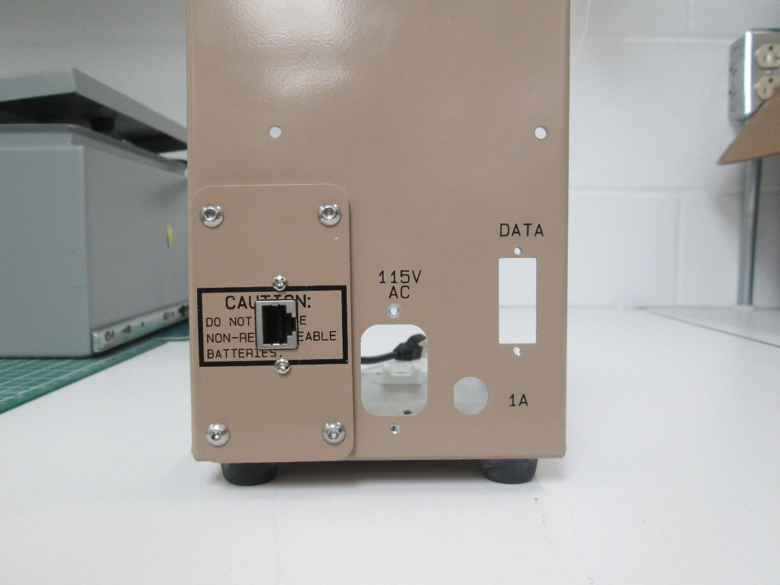

Figure 9: Ethernet Jack Holding Bracket Installation

### Ludlum 2000 Ethernet Metal Plate Installation

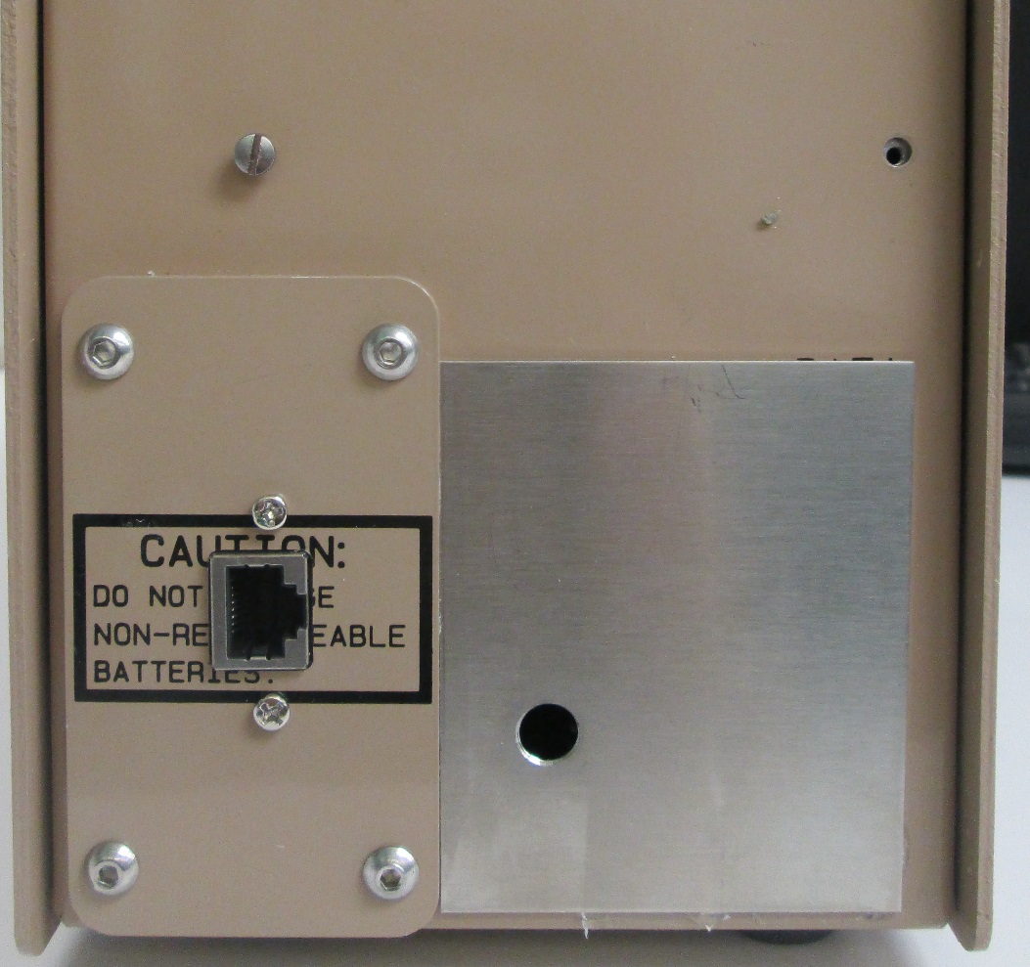

Figure 10: Ludlum 2000 Ethernet Metal Plate Installation

## **Ludlum 2000 Rate Meter PCB Holding Bracket Preparation**

|  |  |  |
| --- | --- | --- |
| Ludlum 2000 Rate Meter PCB Holding Bracket | | |
| Procedure | Test Result | Technician (Initial for conformity) |
| Ludlum 2000 Rate Meter PCB Holding Bracket | | |
| Drill two hole on the metal cage that hold the expansion card to install the microcontroller PCB board.  Note: The hole shall be big enough for a M3 Screw size.    Refer to Figure: for detail | 🞏 Pass  🞏 Fail |  |

Table 12: Ludlum 2000 Rate Meter PCB Holding Bracket

## **Ludlum 2000 Rate Meter Electrical Preparation**

* DC Input Module Electrical Wiring Preparation.
* Ludlum 2000 Rate Meter Electrical Wiring (Supply Voltage)
* Ludlum 2000 Rate Meter Data Cable Preparation

## **Ludlum 2000 Rate Meter Power Supply Board Preparation**

|  |  |  |
| --- | --- | --- |
| Ludlum 2000 Rate Meter Power Supply Board Preparation | | |
| Procedure | Test Result | Technician (Initial for conformity) |
| Ludlum 2000 Rate Meter Power Supply Board Preparation  Rectifier Diode removal | | |
| Using an electronic welding station, desolder the rectifier diode form the Ludlum 2000 Rate Meter Power Supply Board.  Refer to the figure for the exact position of the rectifier diode. | 🞏 Pass  🞏 Fail |  |
| Using an electronic welding station, Install electrical pigtail wire to bridge rectifier diode.  Refer to the figure for the exact position of the pigtail wire | 🞏 Pass  🞏 Fail |  |

Figure 11: Ludlum 2000 Rate Meter Power Supply Board Preparation

### Ludlum 2000 Rate Meter Power Supply Board Preparation

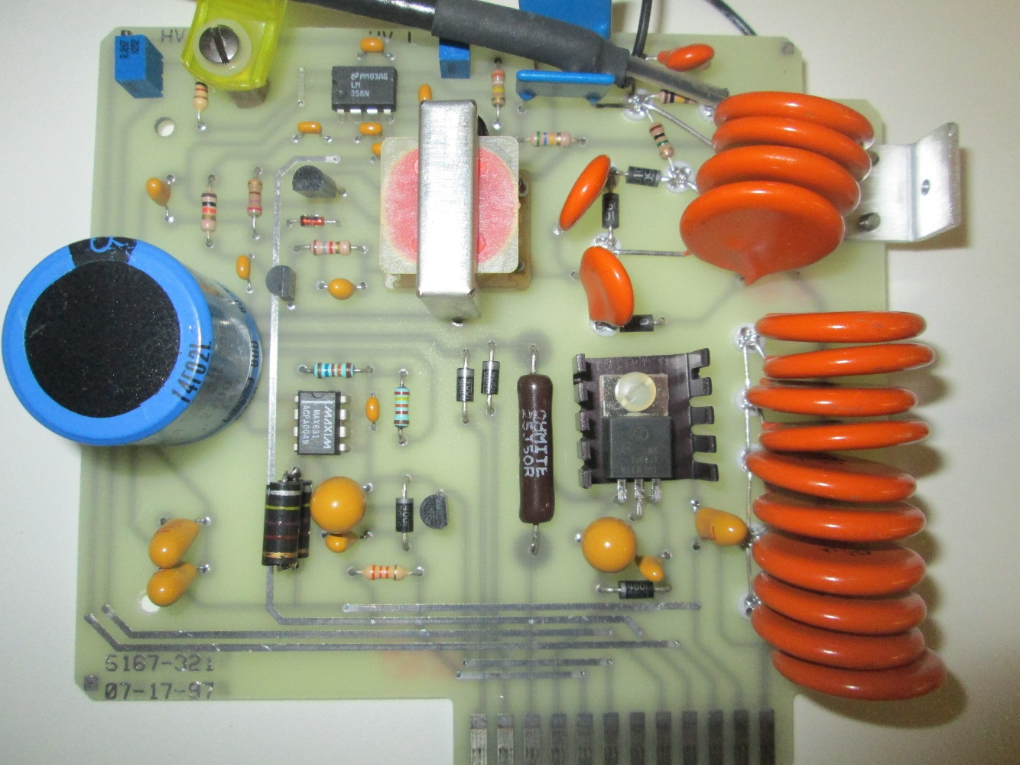

Rectifier Diode.

To be desolder and replaced with pigtail wire

Figure 12: Ludlum 2000 Rate Meter Power Supply Board Preparation

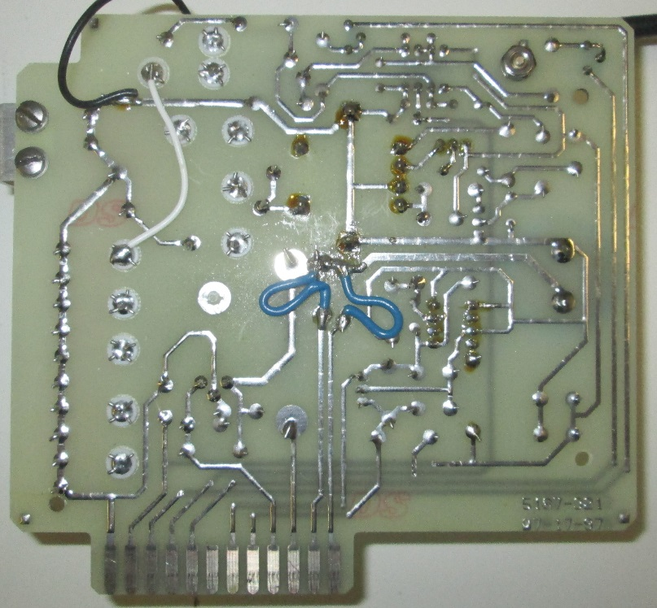

Pigtail Wire

Figure 13: Ludlum 2000 Rate Meter Power Supply Board Preparation

## **Ludlum 2000 Rate Meter Electrical Wiring (DC Power)**

Ludlum 2000 Rate Meter Electrical Wiring (Supply Voltage)

|  |  |  |
| --- | --- | --- |
| Ludlum 2000 Rate Meter Electrical Wiring (DC Power) | | |
| Procedure | Test Result | Technician (Initial for conformity) |
| Ludlum 2000 Rate Meter  Electrical Wiring (DC Power) Preparation | | |
| Remove the red electrical wire for the Ludlum 2000 Rate Meter cable loom.  Just pull on the red electrical wire for the Ludlum 2000 Rate Meter cable loom.  Dispose of the Red electrical wire. | 🞏 Pass  🞏 Fail |  |
| Using an appropriate wire stripper.  Strip the end of the wire rap from the power transformer and battery holder cable loom. | 🞏 Pass  🞏 Fail |  |
| Remove the Black (From the power transformer center tap terminal) electrical wire for the Ludlum 2000 Rate Meter cable loom.  Just pull on the black electrical wire for the Ludlum 2000 Rate Meter cable loom.  Remove the white electrical wire for the Ludlum 2000 Rate Meter cable loom.  Just pull on the white electrical wire for the Ludlum 2000 Rate Meter cable loom. | 🞏 Pass  🞏 Fail |  |
| Ludlum 2000 Rate Meter  Electrical wire harness preparation | | |
| * Using an appropriate wire stripper. Strip the end of both orange cable form the Ludlum 2000 Rate Meter cable loom. * Using an appropriate wire stripper. Strip the end of the White and purple wire from the Ludlum 2000 Rate Meter cable loom. * Using an appropriate wire stripper. Strip the end of the Blue wire from the Ludlum 2000 Rate Meter cable loom. | 🞏 Pass  🞏 Fail |  |
| Ludlum 2000 Rate Meter  GND Terminal Preparation | | |
| Using an electronic welding station.  Remove the black wire from the GND Terminal. | 🞏 Pass  🞏 Fail |  |
| Make sure the electrical cable used for the GND is the right color and size.  This is the color standard used for the assembly of the DC Input supply wire Assembly is :   * Blue/White electrical wire, 20AWG: WesBell Electronics – UL1007-20-26- Hook-Up Wire 20 AWG Blue/White or equivalent.   Note: The electrical wire shall have an approximate length of 10". |  |  |
| * Electrical Wire Preparation   Using an appropriate wire stripper, strip the end of both Blue/White wire.  Using an electronic welding station:   * Electrical Wire Installation   Weld the two section of Blue/white electrical to the GND Terminal on the Ludlum 2000 Rate Meter cable loom.   * Heat Shrink Tube Installation:   Install heat shrink tubing on the GND Terminal  Note 1: The heat shrink tube shall be 7mm in diameter  Using a heat gun shrink the heat shrink tube around the GND Terminal. |  |  |
| Ludlum 2000 Rate Meter  DC Input Supply Preparation | | |
| Make sure the electrical cable used for the DC Input supply is the right color and size.  This is the color standard used for the assembly of the DC Input supply wire Assembly is :   * Blue electrical wire, 20AWG: WesBell Electronics – UL1007-20-26- Hook-Up Wire 20 AWG Blue or equivalent.   Note: The electrical wire shall have an approximate length of 10" | 🞏 Pass  🞏 Fail |  |
| Ludlum 2000 Rate Meter  DC Input Supply Preparation  Wire Preparation | | |
| * Electrical Wire Preparation   Using an appropriate wire stripper, strip both end of the blue wire.  Using an electronic welding station:   * Electrical Wire Installation   Weld a section of blue electrical to the end of the blue wire on the Ludlum 2000 Rate Meter cable loom.   * Heat Shrink Tube Installation:   Install heat shrink tubing on the blue electrical wire.  Using a heat gun shrink the heat shrink tube around the electrical wire.  Note 1: The heat shrink tube shall be 4mm in diameter | 🞏 Pass  🞏 Fail |  |
| Ludlum 2000 Rate Meter  Control Switch Preparation  Wire Preparation | | |
| Twist together both Orange electrical wire from the Ludlum 2000 Rate Meter cable loom. | 🞏 Pass  🞏 Fail |  |
| Ludlum 2000 Rate Meter  Control Switch Preparation | | |
| Make sure the electrical cable used for the DC Input supply is the right color and size.  This is the color standard used for the assembly of the DC Input supply wire Assembly is :   * Blue electrical wire, 20AWG: WesBell Electronics – UL1007-20-26- Hook-Up Wire 20 AWG Blue or equivalent.   Note: The electrical wire shall have an approximate length of 10" | 🞏 Pass  🞏 Fail |  |
| * Electrical Wire Preparation   Using an appropriate wire stripper, strip both end of the blue wire.  Using an electronic welding station:   * Electrical Wire Installation   Weld a section of blue electrical to the end of the orange wire on the Ludlum 2000 Rate Meter cable loom.   * Heat Shrink Tube Installation:   Install heat shrink tubing on the white and purple electrical wire.  Note 1: The heat shrink tube shall be 4mm in diameter  Weld the withe and purple wire from the Ludlum 2000 Rate Meter cable loom to the orange and blue wire  Using a heat gun shrink the heat shrink tube around the electrical wire. | 🞏 Pass  🞏 Fail |  |
| Secure the Ludlum 2000 Rate Meter cable loom with tie rap. | 🞏 Pass  🞏 Fail |  |

Table 13: Ludlum 2000 Rate Meter Electrical Wiring (DC Power)

### Ludlum 2000 Rate Meter Wire Loom Electrical wire harness preparation

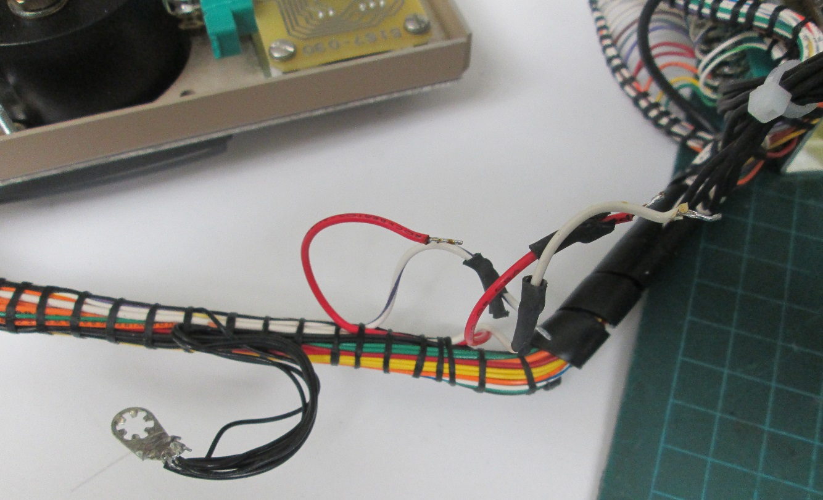

Just pull on the red electrical wire from the Ludlum 2000 Rate Meter cable loom to remove it. Dispose of the Red electrical wire.

Figure 14: Ludlum 2000 Rate Meter Wire Loom Electrical wire harness preparation

Strip the end of the wire rap

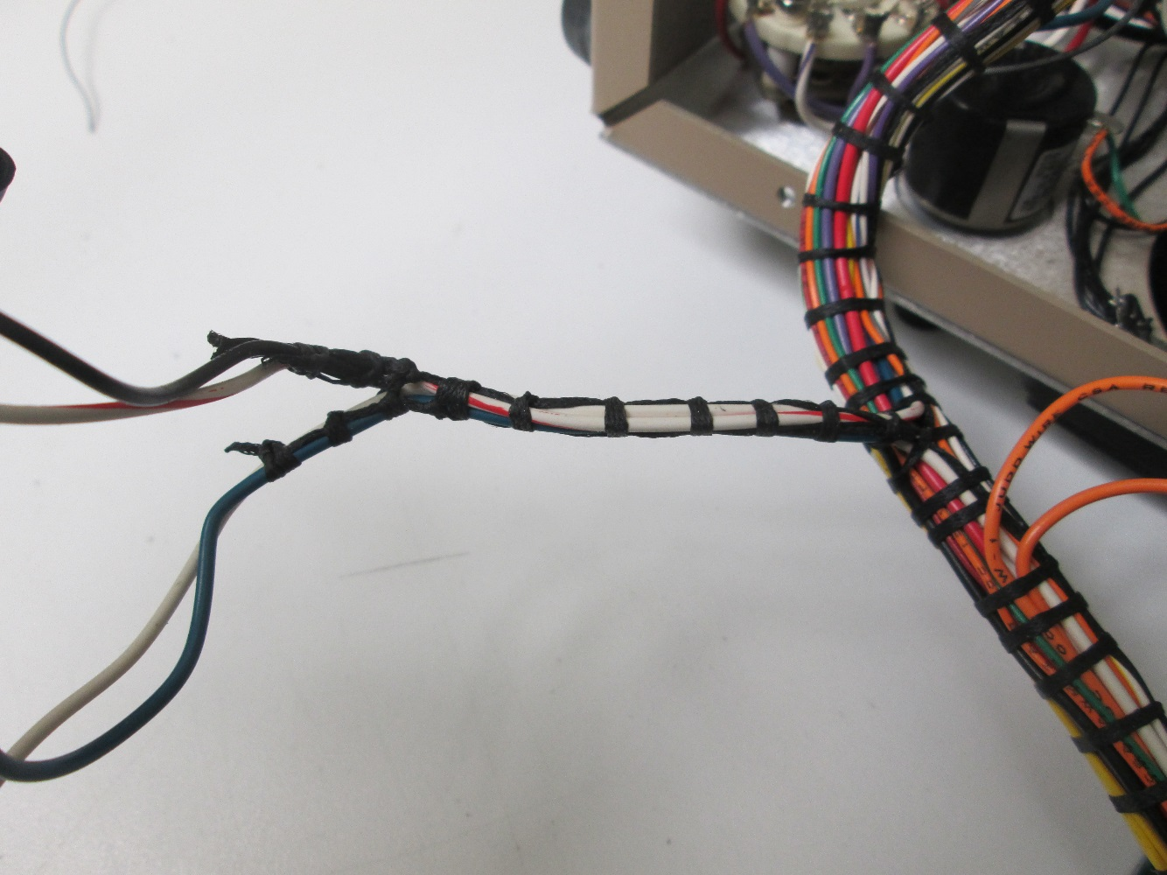

Figure 15: Power transformer and battery holder cable loom

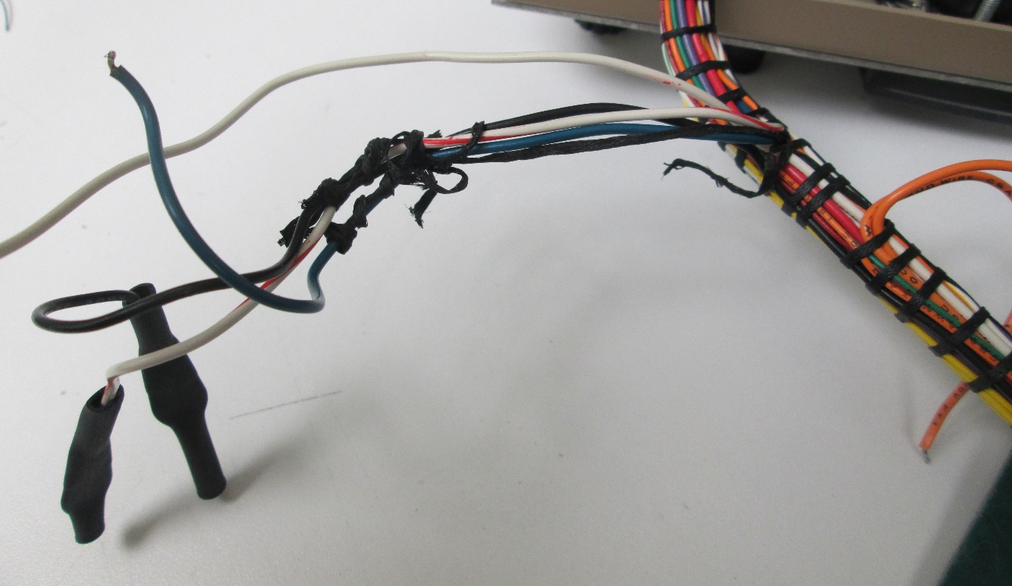

Just pull on the white electrical wire from the Ludlum 2000 Rate Meter cable loom to remove it. Dispose of the white electrical wire.

Figure 16: Ludlum 2000 Rate Meter Wire Loom Electrical wire harness preparation

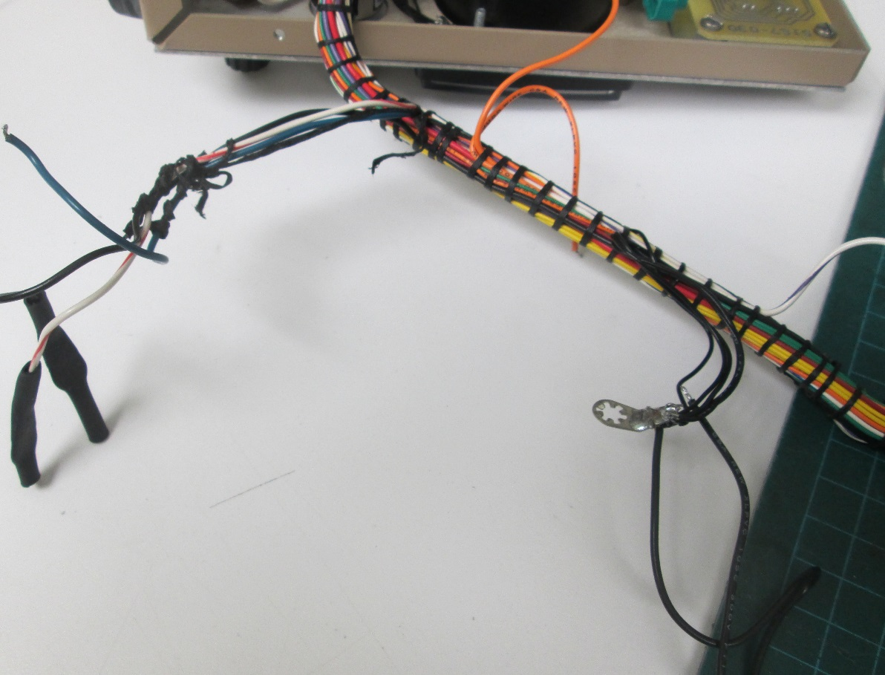

Just pull on the black electrical wire from the Ludlum 2000 Rate Meter cable loom to remove it.

Desolder the black electrical from the GND Terminal.

Dispose of the black electrical wire.

Figure 17: Ludlum 2000 Rate Meter Wire Loom Electrical wire harness preparation

### Ludlum 2000 Rate Meter DC Input Supply Preparation

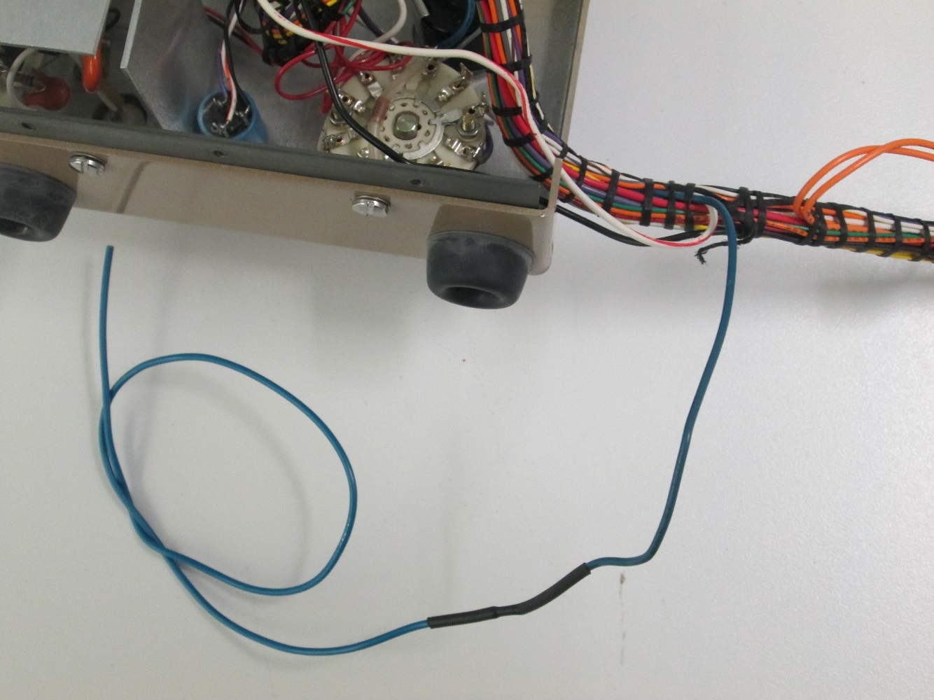

Figure 18: Ludlum 2000 Rate Meter DC Input Supply Preparation

* Electrical Wire Preparation

Using an appropriate wire stripper, strip both end of the blue wire.

Using an electronic welding station:

* Electrical Wire Installation

Weld a section of blue electrical to the end of the blue wire on the Ludlum 2000 Rate Meter cable loom.

* Heat Shrink Tube Installation:

Install heat shrink tubing on the blue electrical wire.

Using a heat gun shrink the heat shrink tube around the electrical wire.

### Control Switch Ludlum 2000 Rate Meter

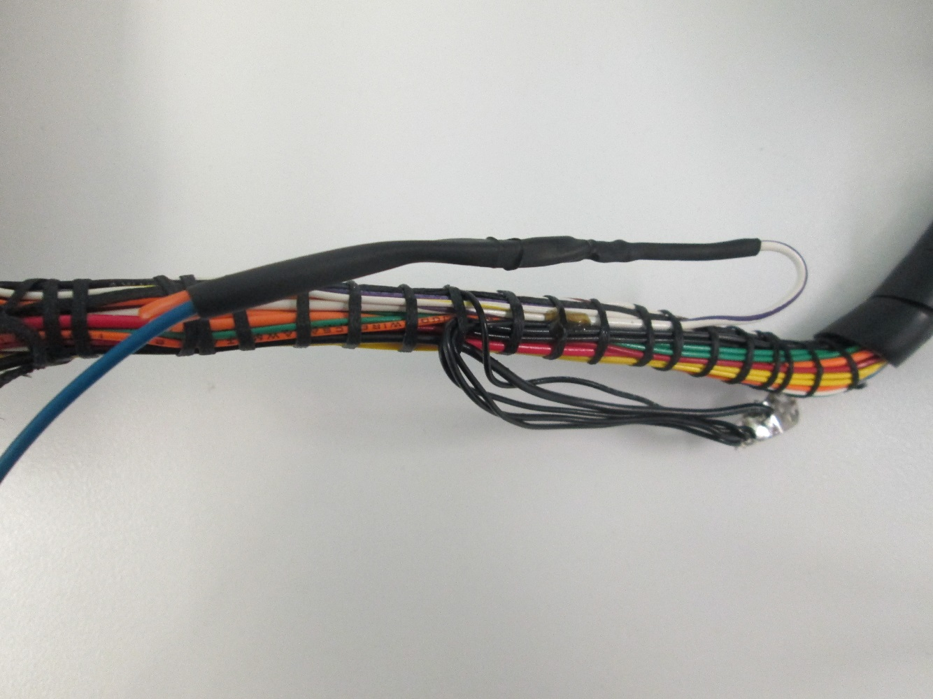

Figure 19: Control Switch Ludlum 2000 Rate Meter

* Electrical Wire Preparation

Using an appropriate wire stripper, strip both end of the blue wire.

Using an electronic welding station:

* Electrical Wire Installation

Weld a section of blue electrical to the end of the orange wire on the Ludlum 2000 Rate Meter cable loom.

* Heat Shrink Tube Installation:

Install heat shrink tubing on the white and purple electrical wire.

Note 1: The heat shrink tube shall be 4mm in diameter

Weld the withe and purple wire from the Ludlum 2000 Rate Meter cable loom to the orange and blue wire

Using a heat gun shrink the heat shrink tube around the electrical wire.

### GND Terminal Ludlum 2000 Rate Meter

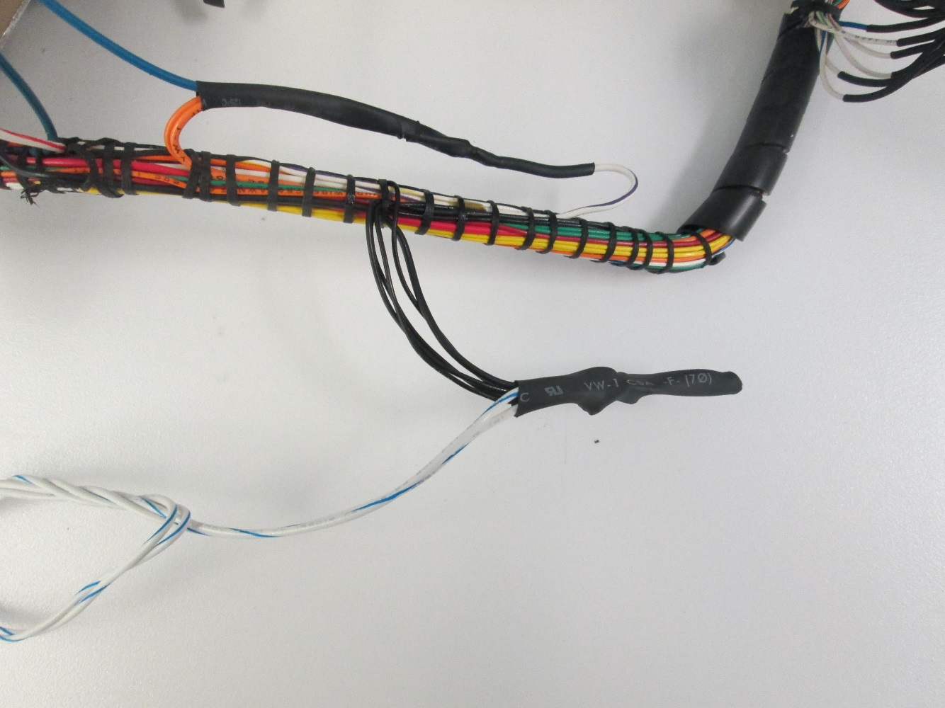

Figure 20: GND Terminal Ludlum 2000 Rate Meter

* Electrical Wire Preparation

Using an appropriate wire stripper, strip the end of both Blue/White wire.

Using an electronic welding station:

* Electrical Wire Installation

Weld the two section of Blue/white electrical to the GND Terminal on the Ludlum 2000 Rate Meter cable loom.

* Heat Shrink Tube Installation:

Install heat shrink tubing on the GND Terminal

Note 1: The heat shrink tube shall be 7mm in diameter

Using a heat gun shrink the heat shrink tube around the GND Terminal.

### Ludlum 2000 Rate Meter Wire Loom completion

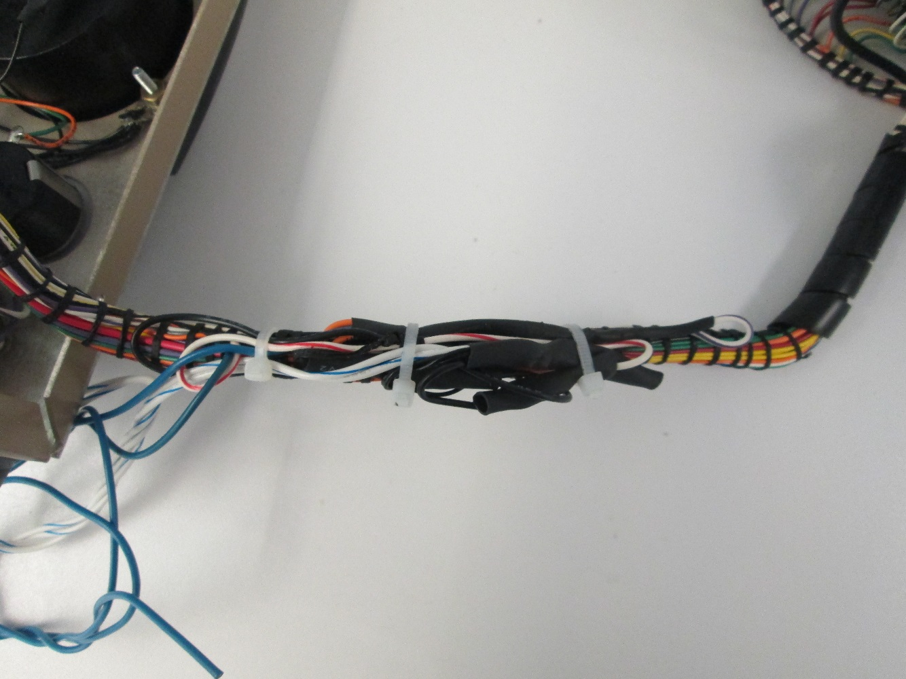

Figure 21: Ludlum 2000 Rate Meter Wire Loom completion

Secure the Ludlum 2000 Rate Meter cable loom with tie rap.

## **Ludlum 2000 Rate Meter Power Input Jack Installation**

|  |  |  |
| --- | --- | --- |
| Ludlum 2000 Rate Meter Power Input Jack Installation | | |
| Procedure | Test Result | Technician (Initial for conformity) |
| Ludlum Rate Meter Preparation  "DC Power supply Wiring" | | |
| Cute the Blue/White electrical wire and the Blue electrical from the Ludlum 2000 Rate Meter cable loom for them to have the same length.   * Electrical Wire Preparation   Using an appropriate wire stripper, strip the end of the blue wire and the blue/white wire. | 🞏 Pass  🞏 Fail |  |
| Ludlum Rate Meter Preparation  "DC Jack" electrical wire connection Procedure | | |
| Install heat shrink tube around the blue wire and the blue/white wire flying lead form the Ludlum Rate Meter cable loom.  Note: When you install the heat shrink tube make sure you cute the heat shrink tube short enough to make the connection between the flying lead form the Ludlum Rate Meter cable loom and the DC jack. | 🞏 Pass  🞏 Fail |  |
| Ludlum Rate Meter Preparation  DC Jack Connector assembly Preparation | | |
| Using an electronic welding station, weld the flying lead from the Ludlum 2000 Rate Meter flying lead to the DC jack.  Connect the Blue electrical wire to the center pin on the DC Jack.  Connect the Blue/White wire to the outside barrel of the DC Jack.  Note: The DC Jack must be Switchcraft Model: 722A or equivalent. | 🞏 Pass  🞏 Fail |  |

Figure 22: Ludlum 2000 Rate Meter Power Input Jack Installation

### Ludlum 2000 Rate Meter Power Input Jack Installation

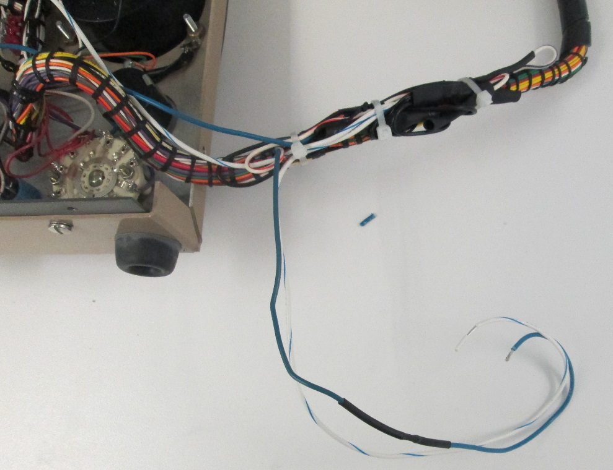

Cute the Blue/White electrical wire and the Blue electrical from the Ludlum 2000 Rate Meter cable loom for them to have the same length.

Figure 23: Ludlum 2000 Rate Meter Power Input Jack Installation

Install heat shrink tube around the blue wire and the blue/white wire flying lead form the Ludlum Rate Meter cable loom.

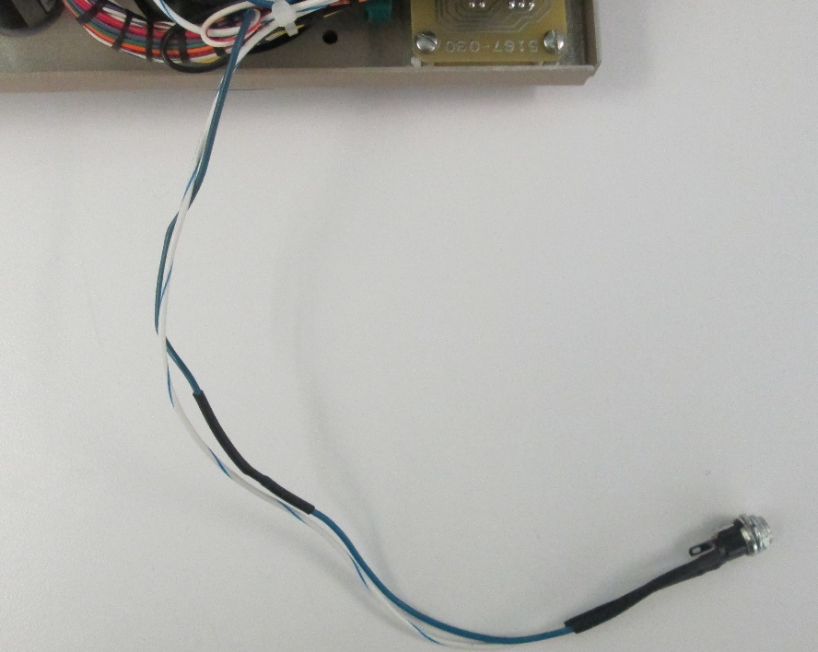

Using an electronic welding station, weld the flying lead from the Ludlum 2000 Rate Meter flying lead to the DC jack.

Connect the Blue electrical wire to the center pin on the DC Jack.

Connect the Blue/White wire to the outside barrel of the DC Jack.

Figure 24: Ludlum 2000 Rate Meter Power Input Jack Installation

## **Ludlum 2000 Rate Meter Data Cable Preparation**

|  |  |  |
| --- | --- | --- |
| Ludlum 2000 Rate Meter Data Cable Preparation | | |
| Procedure | Test Result | Technician (Initial for conformity) |
| Ludlum Rate Meter Preparation  "Data Connector" | | |
| Remove the two screw that hold the "Data connector" to the Ludlum 2000 rate Meter back enclose  Pull the "Data connector" out of the enclosure to expose the connecting wire. | 🞏 Pass  🞏 Fail |  |
| Ludlum Rate Meter Preparation  "Data Connector" electrical wire splicing | | |
| Cut the electrical wire connected to the "Data connector".  The electrical wire need to be splice to the new connector, the new connector will connect the Ludlum Rate Meter wire to the new PCB board. | 🞏 Pass  🞏 Fail |  |
| Ludlum Rate Meter Preparation  "Data Connector" electrical wire connection Procedure | | |
| Using an appropriate wire stripper, strip each flying lead form the Ludlum Rate Meter "Data connector".  Install heat shrink tube around the flying lead form the Ludlum Rate Meter "Data connector".  Note: When you install the heat shrink tube make sure you cute the heat shrink tube short enough to make the connection between the flying lead form the Ludlum Rate Meter and the JST-XH-8P, JST-XH-4P Connector assembly (Wire). | 🞏 Pass  🞏 Fail |  |
| JST-XH-8P JST-XH-4P Connector assembly Preparation | | |
| Using an appropriate wire stripper, strip each flying lead form the JST-XH-8P Connector assembly  The length of insulation layer to be strip is approximately 1/8" or 0.31cm. | 🞏 Pass  🞏 Fail |  |
| Using an appropriate wire stripper, strip each flying lead form the JST-XH-4P Connector assembly  The length of insulation layer to be strip is approximately 1/8" or 0.31cm. | 🞏 Pass  🞏 Fail |  |
| Ludlum 2000 Rate Meter Final Connexion | | |
| Using an electronic welding station, weld the flying lead from the JST-XH-8P Connector to the Ludlum 2000 Rate Meter flying lead.  Follow the Table 5: (Ludlum 2000 Rate Meter Communication Connector) for the exact function and allocation of pin header on the Ludlum 2000 Rate Meter Communication Connector Assembly | 🞏 Pass  🞏 Fail |  |
| Using a heat gun shrink the heat shrink tube around the flying lead form the Ludlum Rate Meter "Data connector" and the JST-XH-8P Connector.  Make sure that each electrical wire are correctly insulated by the heat shrink tube. | 🞏 Pass  🞏 Fail |  |
| Using a heat gun shrink the heat shrink tube around the  Flying lead form the Ludlum Rate Meter "Data connector" and the JST-XH-4P Connector.  Make sure that each electrical wire are correctly insulated by the heat shrink tube. | 🞏 Pass  🞏 Fail |  |

Table 14: Ludlum 2000 Rate Meter Data Cable Preparation

### **Ludlum 2000 Rate Meter "Data Connector" Control Signal**

|  |  |  |  |
| --- | --- | --- | --- |
| Ludlum 2000 Rate Meter "Data Connector" | | | |
| Ludlum 2000 Rate Meter "Data Connector"  Pin Allocation | Color of the Electrical Wire  (Ludlum 2000 Rate Meter) | Function of the Electrical Wire | Other Information |
| Ludlum 2000 Rate Meter "Data Connector"  Control signal | | | |
|  | Orange | Count Complet | When the Ludlum 2000 Rate Meter has timed and counting stops. A "HI" pulse appears on pin 1 "Count Complet". This pulse is approximately 2 milliseconds wide and is used to signal the accessory unit that data is ready to be transmitted. |
|  | White/Yellow | Printer Ready | When the accessory unit is ready to accept the data, pin 2 "Printer Ready" is pulsed "HI" for a minimum of 10 milliseconds. When this pin goes "LOW", data is unloaded from the Ludlum 2000 Rate Meter. |
|  | Orange/White | Load Printer | The pin 3 "Load Printer" goes "HI" when the "Print Ready" pin 2. The he pin 3 "Load Printer" goes "LOW" when the Data transfer is complet. |
|  | Black/White | Printer Clock | "Printer Clock" "Pin 4" Clock Pulse. Clocking |
|  | Black | Ground | Ground signal Reference |
|  | Gray | Count | To start the Ludlum 2000 Rate Meter the pin 6 "Count" is set LOW for a minimum of 100 milliseconds |
|  | Purple | Hold | To Stop the Ludlum 2000 Rate Meter the pin 7 "Hold" is set LOW for a minimum of 100 milliseconds |
|  | Red | +4 to +6 DC Volts | Reference Voltage |
|  | N.A | N.A | N.A |
|  | Bleu | +10 DC Volts | Reference Voltage |
|  | Red/White | Blanking | N.A |

Table 15: Ludlum 2000 Rate Meter "Data Connector"

### **Ludlum 2000 Rate Meter "Data Connector" Data Output**

|  |  |  |  |
| --- | --- | --- | --- |
| Ludlum 2000 Rate Meter "Data Connector" | | | |
| Ludlum 2000 Rate Meter "Data Connector"  Pin Allocation | Color of the Electrical Wire | Function of the Electrical Wire | Other Information |
| Ludlum 2000 Rate Meter "Data Connector"  Control signal | | | |
|  | Brown/White | Bit 1 | Bit 1 (1) Least Significant Bit (LSB)  BCD Format |
|  | Green/White | Bit 2 | Bit 2 (2)  BCD Format |
|  | Blue/White | Bit 3 | Bit 3 (4)  BCD Format |
|  | Gray/white | Bit 4 (8) | Bit 3 (8) Most Significant bit (MSB)  BCD Format |

Table 16: Ludlum 2000 Rate Meter "Data Connector"

### **Ludlum 2000 Rate Meter to Interface Connector (Control Signal)**

|  |  |  |  |
| --- | --- | --- | --- |
| Ludlum 2000 Rate Meter to Interface Connector (Control Signal) | | | |
| Color of the Electrical Wire  (Ludlum 2000 Rate Meter) | JST-XH-10P Connector Wire Color | Function of the Electrical Wire | Other Information |
| Ludlum 2000 Rate Meter to Interface Connector (Control Signal) | | | |
| Orange | Black | Count Complet | When the Ludlum 2000 Rate Meter has timed and counting stops. A "HI" pulse appears on pin 1 "Count Complet". This pulse is approximately 2 milliseconds wide and is used to signal the accessory unit that data is ready to be transmitted. |
| White/Yellow | Red | Printer Ready | When the accessory unit is ready to accept the data, pin 2 "Printer Ready" is pulsed "HI" for a minimum of 10 milliseconds. When this pin goes "LOW", data is unloaded from the Ludlum 2000 Rate Meter. |
| Orange/White | White | Load Printer | The pin 3 "Load Printer" goes "HI" when the "Print Ready" pin 2. The he pin 3 "Load Printer" goes "LOW" when the Data transfer is complet. |
| Black/White | Yellow | Printer Clock | "Printer Clock" "Pin 4" Clock Pulse. Clocking |
| Black | Orange | Ground | Ground signal Reference |
| Gray | Green | Count | To start the Ludlum 2000 Rate Meter the pin 6 "Count" is set LOW for a minimum of 100 milliseconds |
| Purple | Bleu | Hold | To Stop the Ludlum 2000 Rate Meter the pin 7 "Hold" is set LOW for a minimum of 100 milliseconds |
| Red | Purple | +4 to +6 DC Volts | Reference Voltage |
| Bleu | Gray | +10 DC Volts | Reference Voltage |
| Red/White | Brown | Blanking | N.A |

Figure 25: Ludlum 2000 Rate Meter to Interface Connector (Control Signal)

### **Ludlum 2000 Rate Meter to Interface Connector (Data Output)**

|  |  |  |  |
| --- | --- | --- | --- |
| Ludlum 2000 Rate Meter Interface Connector (Data Output) | | | |
| Ludlum 2000 Rate Meter "Data Connector"  Pin Allocation | Color of the Electrical Wire  JST-XH-4P Connector Wire Color | Function of the Electrical Wire | Other Information |
| Ludlum 2000 Rate Meter Interface Connector (Data Output) | | | |
| Brown/White | Yellow | Bit 1 | Bit 1 (1) Least Significant Bit (LSB)  BCD Format |
| Green/White | White | Bit 2 | Bit 2 (2)  BCD Format |
| Blue/White | Red | Bit 3 | Bit 3 (4)  BCD Format |
| Gray/white | Black | Bit 4 (8) | Bit 3 (8) Most Significant bit (MSB)  BCD Format |

Figure 26: Ludlum 2000 Rate Meter Interface Connector (Data Output)

### **Ludlum 2000 Rate Meter Interface Connector**

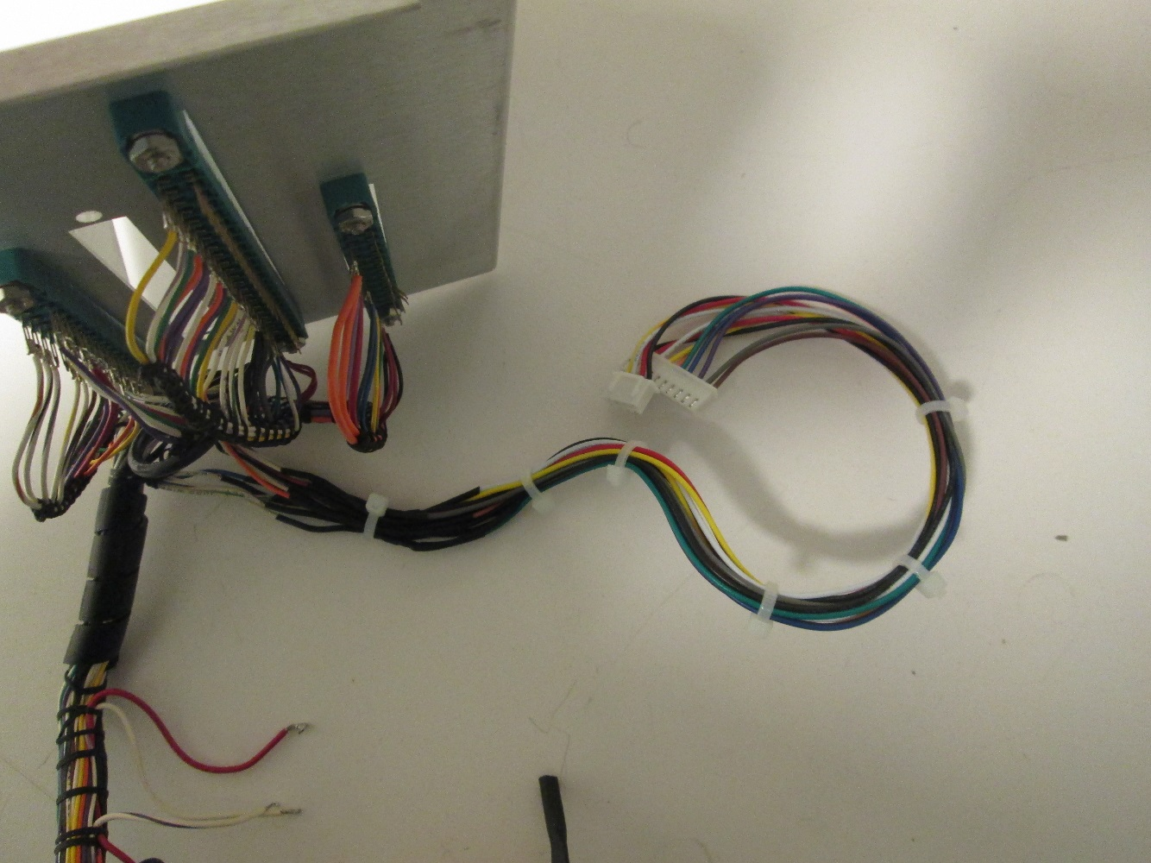

Table 17: Ludlum 2000 Rate Meter Interface Connector

**Ludlum 2000 Rate Meter Final Installation**

* Ludlum 2000 Rate Meter Ethernet Module Installation

## **Ludlum 2000 Rate Meter Ethernet Module Installation**

|  |  |  |
| --- | --- | --- |
| Ludlum 2000 Rate Meter Ethernet Module Installation | | |
| Procedure | Test Result | Technician (Initial for conformity) |
| Ludlum 2000 Rate Meter  Ethernet Module Preparation (IDC Cable Installation) | | |
| Install the IDC Cable on the Ethernet Module.  The red wire on the IDC cable must point to VCC and GND pin on the Ethernet module.  Note 1: The IDC Cable is the appropriate length to connect to the Microcontroller PCB Board.  Note 2: The red wire on the IDC cable denote pin 1  Note 3: Refer to section 12.1 of this document for more information | 🞏 Pass  🞏 Fail |  |
| Ludlum 2000 Rate Meter  Ethernet Module Preparation (Protective Heat Shrink) | | |
| Cut a section of heat Shrink tube of approximately 7cm.  Cut the end of the heat Shrink tube to allow the passage of the IDC Cable. The end cut must be approximately 3cm.  Insert the Ethernet Module inside the protective heat Shrink tube.  Install the protective heat Shrink tube over the Ethernet Module.  The heat Shrink tube must be Pro Power Model PP2125 1" Diameter or equivalent. | 🞏 Pass  🞏 Fail |  |
| Ludlum 2000 Rate Meter  Ethernet Module Final Installation | | |
| Connect the Ethernet Jack to the Ethernet Module.  Secure the Ethernet Module to the appropriate holding bracket with tie rap. | 🞏 Pass  🞏 Fail |  |

Table 8: Ludlum 2000 Rate Meter Ethernet Module Installation

### **Ludlum 2000 Rate Meter Ethernet Module Installation**

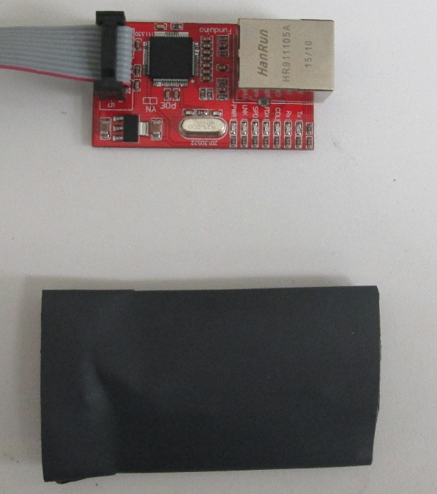

Ethernet Module and protective heat Shrink tube.

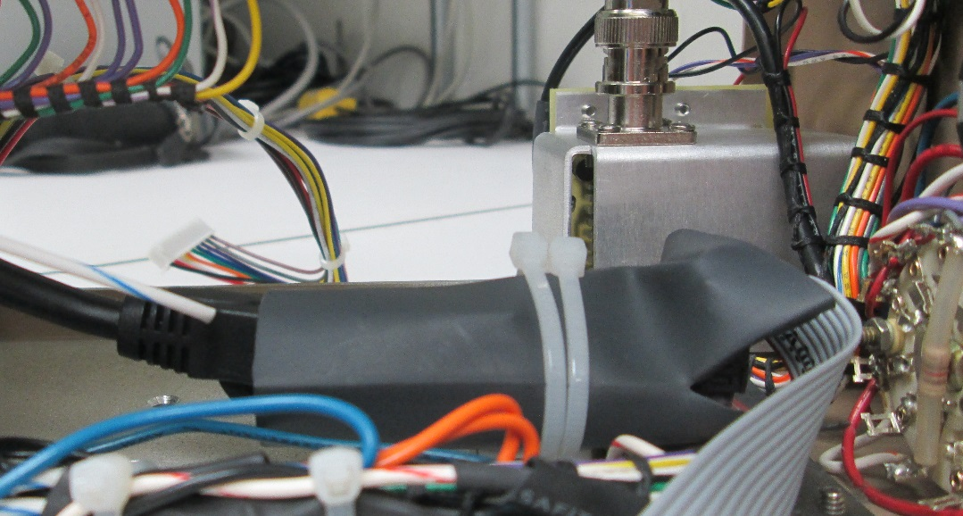

Table 9: Ludlum 2000 Rate Meter Ethernet Module Installation

## **Ludlum 2000 Rate Meter Final Installation**

|  |  |  |
| --- | --- | --- |
| Ludlum 2000 Rate Meter  Final Installation | | |
| Procedure | Test Result | Technician (Initial for conformity) |
| Metal Case Installation | | |
| Secure the DC Power Jack to the hole in the metal plate at the back of the Ludlum 2000 Rate Meter. | 🞏 Pass  🞏 Fail |  |
| Expansion card holding bracket installation | | |
| Install the Expansion card holding bracket in place and secure with the appropriate screw.  Install the expansion card in place and secure with appropriate screw. | 🞏 Pass  🞏 Fail |  |
| Microcontroller Power supply Wiring (Low Voltage) | | |
| Using an appropriate wire stripper, strip both end of the bleu and bleu/White wire. | 🞏 Pass  🞏 Fail |  |
| * Connect the "Bleu" electrical wire flying to the "+V" terminal block on the power supply. * Connect the "Bleu/White" electrical wire flying to the "-V" terminal block on the power supply.   Note 1: Install the electrical wire in an appropriate fashion. | 🞏 Pass  🞏 Fail |  |
| Microcontroller PCB Board Installation | | |
| Power supply connection:   * Connect the "Bleu" electrical wire flying to the "+V" terminal block on the Microcontroller PCB Board. * Connect the "Bleu/White" electrical wire flying to the "-V" terminal block on the Microcontroller PCB Board.   Data Connector Installation:   * Connect the 10 pin interface cable to the appropriate connector on the PCB Board. * Connect the 4 pin interface cable to the appropriate connector on the PCB Board.   Microcontroller PCB Board Mounting  Secure the Microcontroller PCB Board with appropriate screw to the expansion card holding bracket.  Note: The Microcontroller PCB Board is pre-assemble and tested before final installation.  Refer to annex of this document for assembly and programming | 🞏 Pass  🞏 Fail |  |

Table 18: Ludlum 2000 Rate Meter Power Transformer and Ground Bushing Installation

Ludlum 2000 Rate Meter Assembly Document Annex

* Ludlum 2000 Rate Meter Telnet Server
* Atmega1284P Minimal Board (Electronic Preparation)
* Install the Boot Loader (Boot Loader Programming)
* Capsule Counter Uploading the programme
* ArduinoTM Programming Environment Preparation
* ArduinoTM programming environment overview

## **Ludlum 2000 Rate Meter Telnet Server**

Ludlum 2000 Rate Meter Telnet Server

1. General Information

Network Information:

The ip Adress for the Ludlum 2000 Rate Meter Telnet Server can be automaticaly assigned by a DHCP server or manualy set in the code of the microcontroller.

Ip: Adress 192.168.2.100

( IP Adress set by default for testing purpose)

Port: 23

The Telnet Software used for demonstation and test is : AbsoluteTelnet

The software is available free of charge at the following website:

[www.celestialsoftware.net](http://www.celestialsoftware.net)

Install the telnet server on the remote computer.

Connect to the telnet server with the information provided.

### **Ludlum 2000 Telnet Server Welcome Page**

Establish a communication with the telnet server: when the communication with the telnet server is successfully. The following page is display on the telnet client software

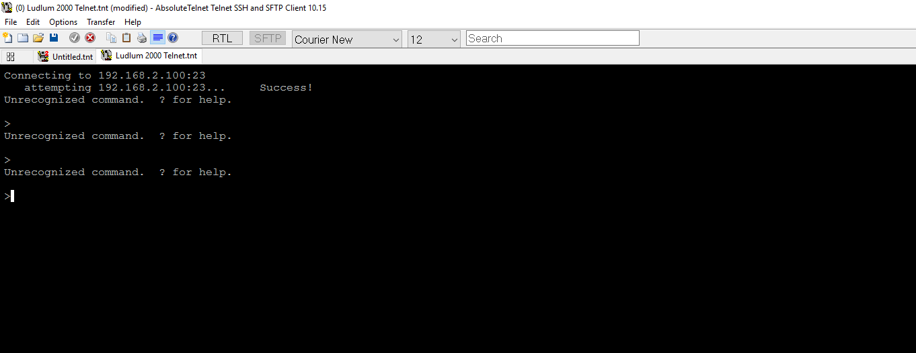

Figure 27: Ludlum 2000 Telnet Server Welcome

### **Ludlum 2000 Telnet Server Commands Page**

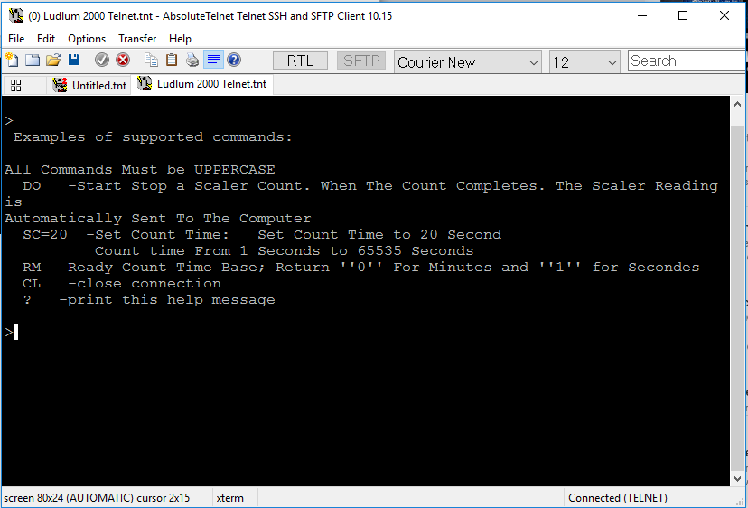

Figure 28: Ludlum 2000 Commands Page

### **Ludlum 2000 Rate Meter Telnet Server: List Of Available Function**

|  |  |
| --- | --- |
| Ludlum 2000 Rate Meter  Telnet Server: List Of available Function | |
| Name Of command | Function of The Command |
| Command: DO  Note 1: All Command Send to the telnet server must be upper case.  Note 2: The text display on the telnet server is also display on the serial console | Start / Stop a Scaler Count  When The count complet.  The Scaler Reading is automatically Sent to the Computer |
| Command: SC  Note 1: All Command Send to the telnet server must be upper case.  Note 2: The text display on the telnet server is also display on the serial console | Set Count Time:  Example SC=20 (Set Count Time to 20 Second)  The Count time can be adjusted From 1 Seconds to 65535 Seconds. |
| Command: CL  Note 1: All Command Send to the telnet server must be upper case.  Note 2: The text display on the telnet server is also display on the serial console | Close connection |
| Command: ?  Note 1: All Command Send to the telnet server must be upper case.  Note 2: The text display on the telnet server is also display on the serial console | Display this help message |

Table 19: Telnet Server: List Of available Function

### **Telnet Server: DO Commands Page**

|  |  |
| --- | --- |
| Ludlum 2000 Rate Meter  Telnet Server: Command DO | |
| Name Of command | Function of The Command |
| Command: DO  Note 1: All Command Send to the telnet server must be upper case.  Note 2: The text display on the telnet server is also display on the serial console.  Note 3: The Ludlum 2000 Rate Meter as a red LED light on the front panel that is light when a count as started. The LED light is off when the Count as stopped.  Note 4: the count value is display on the Ludlum 2000 Rate Meter front panel LED display. | Start / Stop a Scaler Count  When The count complet.  The Scaler Reading is automatically Sent to the Computer.   * The Telnet Server Display that the Ludlum Rate Meter is started. * The Telnet Server Display that the Ludlum Rate Meter as stopped * The Telnet Server display the count Reading |

Table 20: Ludlum 2000 Rate Meter Telnet Server: Command DO

### **Ludlum 2000 Rate Meter Telnet Server: Command DO Page**

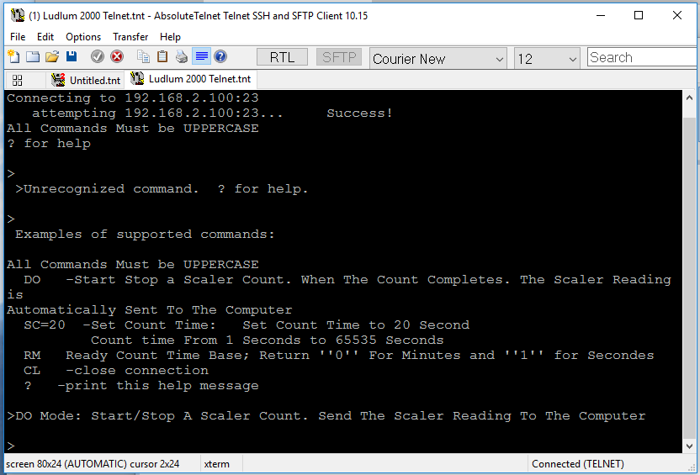

Figure 29: Ludlum 2000 Telnet Server: Command DO

### **Ludlum 2000 Telnet Server SC Commands Page**

|  |  |
| --- | --- |
| Ludlum 2000 Rate Meter  Telnet Server: Command SC | |
| Name Of command | Function of The Command |
| Command: SC  Note 1: All Command Send to the telnet server must be upper case.  Note 2: The text display on the telnet server is also display on the serial console. | Set Count Time:  Example SC=20 (Set Count Time to 20 Second)  The Count time can be adjusted From 1 Seconds to 65535 Seconds.   * The Telnet Server display the Count Time in Second. |

Table 21: Ludlum 2000 Rate Meter Telnet Server: Command SC

### **Ludlum 2000 Telnet Server SC Command Page**

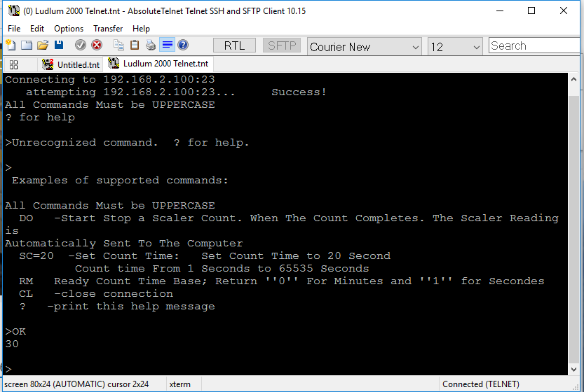

Figure 30: Ludlum 2000 Telnet Server SC commands Page

### **Ludlum 2000 Telnet Server CL Commands Page**

|  |  |
| --- | --- |
| Ludlum 2000 Rate Meter  Telnet Server: Command CL | |
| Name Of command | Function of The Command |
| Command: CL  Note 1: All Command Send to the telnet server must be upper case.  Note 2: The text display on the telnet server is also display on the serial console. | * Close connection with the telnet server |

Table 23: Ludlum 2000 Rate Meter Telnet Server: Command CL

### **Ludlum 2000 Telnet Server CL Commands**

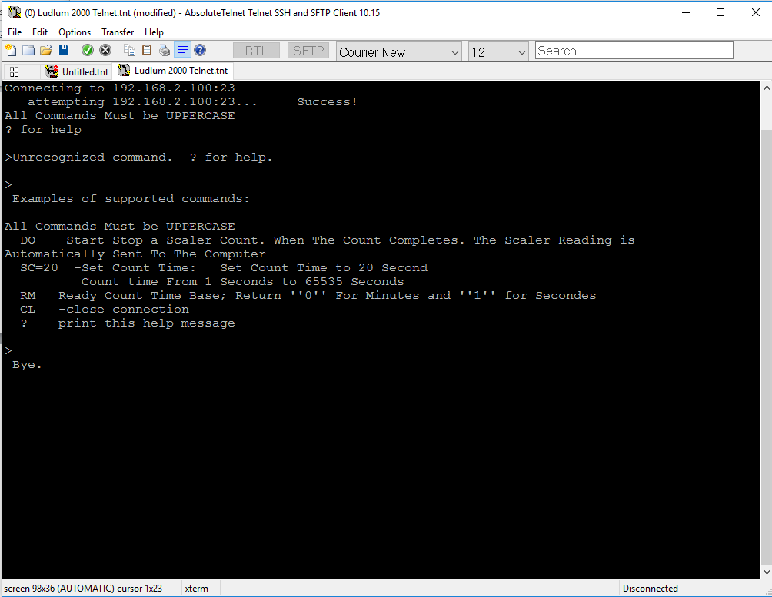

Figure 32: Ludlum 2000 Telnet Server CL commands

### **Ludlum 2000 Telnet Server ? Commands Page**

|  |  |
| --- | --- |
| Ludlum 2000 Rate Meter  Telnet Server: Command ? | |
| Name Of command | Function of The Command |
| Command: ?  Note 1: All Command Send to the telnet server must be upper case.  Note 2: The text display on the telnet server is also display on the serial console. | * Display this help message |

Table 24: Ludlum 2000 Rate Meter Telnet Server: Command?

### **Ludlum 2000 Telnet Server ? Commands**



Figure 33: Ludlum 2000 Telnet Server CL commands

## **Microcontroller Boot Loader Installation**

**Warning:**

**Use the following instruction at your own risk. Damage to the Ludlum 2000 Rate Meter PCB or microcontroller may result.**

Introduction:

The microcontroller installed on the Ludlum 2000 rate Meter PCB Board came with no boot loader and programme installed. The following procedure at intended for the installation of the Boot Loader software on the microcontroller chip.

The installation of the boot loader on the microcontroller chip is required in the following event.

* The microcontroller chip on the Ludlum 2000 Rate Meter PCB Board as to be replaced.
* New Ludlum 2000 Rate Meter PCB Board as to be produced.

Note 1: Five PCB replacement unit has been assemble and tested, following the completion of the project.

### **ArduinoTM Programming Environment Preparation**

* Install the ArduinoTM Software on the target computer:

The software is available (Free of charge) at the following website:

<https://www.arduino.cc/en/Main/Software>. Download the latest version available on the website.

(Install the ArduinoTM Software according to the website information)

* Atmega 1284 (Mighty-1284P Library)

The Library is Available (Free of charge) at the following website:

https://github.com/JChristensen/mighty-1284p/tree/v1.6.3 Download the latest version available on the website.

Installation Instruction

1. Go to <https://github.com/JChristensen/mighty-1284p/tree/v1.6.3>, click the **Download ZIP** button and save the ZIP file to a convenient location on your computer.
2. Ensure that the Arduino IDE is **not** running.
3. Go to your Arduino **hardware** folder.
4. Unzip the downloaded file into the **hardware** folder.
5. The download from GitHub will have a dash and branch name appended, so the folder will be named, e.g. mighty-1284p-v1.6.3. Rename the folder to just **mighty-1284p**.
6. The following folders and files should now exist:
   * hardware\mighty-1284p\avr\bootloaders
   * hardware\mighty-1284p\avr\libraries
   * hardware\mighty-1284p\avr\patched-3rd-party-libs
   * hardware\mighty-1284p\avr\variants
   * hardware\mighty-1284p\avr\boards.txt
   * hardware\mighty-1284p\avr\boards.txt.alt
   * hardware\mighty-1284p.gitignore
   * hardware\mighty-1284p\README.md
7. Move any mighty-1284p compatible 3rd party patched libs under [sketchfolder]\libraries as required. (Note: the mighty-1284p compatible "official" patched libs are already set-up to be used as default when using mighty-1284p by being in avr\libraries. If the wrong libs are being used, check to see that there aren't old versions of the patched libs still under [sketchfolder]\libraries, as those would take precedence.)
8. Restart the Arduino IDE.
9. Select the desired board from the Tools > Board menu and enjoy those extra pins and all that extra memory!

* Ludlum 2000 Rate Meter Time Library

The Time Library is Available (Free of charge) at the following website:

Download the latest version available on the website.

Installation Instruction

(1) Go to <https://github.com/JChristensen/Timer> and click the ZIP button to

download the repository as a ZIP file to a convenient location on your PC.

(2) Uncompress the downloaded file. This will result in a folder containing all

the files for the library, that has a name that includes the branch name,

for example "Time-master".

(3) Rename the folder to just "time".

(4) Copy the renamed folder to the Arduino sketchbook\libraries folder.

Note 1: The ArduinoTM programming environment is available for most of the operating system.

Note 2: All the required software and library for the Ludlum 2000 Rate Meter project are available in the Ludlum 2000 rate Meter Directory.

Note 3: The Ludlum 2000 Rate Meter Programme has been created using the Microsoft WindowsTM environment.

Note 4: Make sure that the Arduino ArduinoTM programming environment software is not running during the installation of library

### **ArduinoTM programming environment overview**

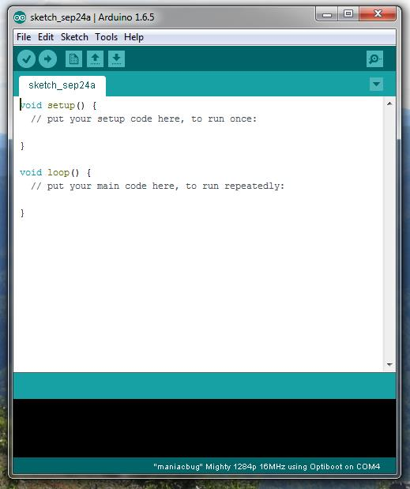

Download to microcontroller Button

Verify Button

Figure 34 : ArduinoTM programming environment overview

The Arduino icon is available in the Microsoft@ Start Menu

### **Arduino Bootloader Programming Sketch Preparation**

The following annex is based on the work of Nick Gammon

All right Reserved

Internet Link to the relevant information: http://www.gammon.com.au/breadboard

Mike Gammon Programming Sketch <https://github.com/nickgammon/arduino_sketches>

Note 1: The boot loader as to be programmed only once. After the boot loader has been programmed inside the microcontroller chip. The Ludlum 2000 Rate Meter programme can be uploaded using the USB to Serial (TTL signal level) converter.

A special header is included with the Ludlum 2000 rate Meter PCB Board.

### **Arduino Bootloader (Atmega 1284 Microcontroller) Cross talk Issue**

* Description of the problem:

The Nick Gammon programming sketch contains a programming error:

The programming error cause Cross talk between the XTAL1 and RX0 pins on the Atmega 1284 Microcontroller.

* Solution to the Cross talk Issue:

Modify the programming sketch form Nick Gammon Fuse setting parameter

Open the programming sketch form Nick Gammon with an appropriate text editor such as Notpad++

The name of the files is: Atmega_Board_Programmer.ino

In the Notpad++ text editor locate the following line: 308.

Change the Fuse Setting according to the following

Save the files

* Change the Low Fuse Setting form:

LFuse: = low_fuses=OxFF (Original)

To

LFuse: = low_fuses=0xF7 (Updated)

The Notpad++ text editor is available (free of charge) at the following link:

<https://notepad-plus-plus.org/fr/>

* Burn the Atmega_Board_Programmer.ino sketch on the programming Arduino uno board
* Complete the electrical wiring according the section 15.5 of this document.
* Install the bootloader according to section 15.6 of this document.

Set the Arduino Serial Terminal to the following: 115200 baud, follow the information display on the Arduino terminal windows.

### Ludlum 2000 Rate Meter PCB Board Electrical Connection

### (Boot Loader Installation)

|  |  |  |
| --- | --- | --- |
| Ludlum 2000 Rate Meter  Electrical Wiring (Line Voltage) | | |
| Procedure | Test Result | Technician (Initial for conformity) |
| Connect an appropriate Nema 5-15P plug to the power supply.  The "Black" electrical wire form the Nema 5-15P plug to the "L" Terminal on the power supply.  The "White" electrical wire form the Nema 5-15P plug to the "N" Terminal on the power supply.  The "Green" electrical wire form the Nema 5-15P plug to the "GND" Terminal on the power supply.  Note 2: The Power supply for the PCB Board must be Mean Well  Model: MDR-20-5  100-240 Vac to 5Vdc or equivalent | 🞏 Pass  🞏 Fail |  |
| Electrical Wiring (Low Voltage) | | |
| * Connect an electrical wire for the "+V" Terminal on the power supply to the "VCC" terminal block on the Ludlum 2000 Rate Meter PCB Board. * Connect an electrical wire for the "-V" Terminal on the power supply to the "GND" terminal block on the Ludlum 2000 Rate Meter PCB Board.   Note: Do not apply power to the Ludlum 2000 Rate Meter PCB Board before all electrical connexion is completed. | 🞏 Pass  🞏 Fail |  |
| Ludlum 2000 Rate Meter PCB Board  Programming Interface wiring | | |
| Ludlum 2000 Rate Meter PCB Board and the Arduino Uno programming board wiring procedure.  **Programming Uno Target board**  Ludlum 2000 Rate Meter  (ISCP Connector)  D10 (SS) Reset – Pin 5  D11 (MOSI) MOSI - Pin 4  D12 (MISO) MISO - Pin 1  D13 (SCK) SCK - Pin 3  Gnd Gnd - Pin 6 | 🞏 Pass  🞏 Fail |  |
| Ludlum 2000 Rate Meter PCB Board  Power UP and Programming Sequence | | |
| * Connect the Arduino Uno to a computer with the appropriate USB Cable.   The computer shall detect the Arduino Uno and install the appropriate driver.   * Connect the Ludlum 2000 Rate Meter PCB Board power supply to an electrical outlet.   The LED light on the Ludlum 2000 Rate Meter PCB Board shall light. | 🞏 Pass  🞏 Fail |  |

Table 25: Ludlum 2000 Rate Meter PCB Board Electrical Connection (Boot Loader Installation)

## **Ludlum 2000 Rate Meter PCB Board (Programme Upload)**

* Disconnect the Arduino Uno form the Ludlum 2000 Rate Meter PCB Board.
* Disconnect the Arduino Uno from the computer.
* Connect the SparkFun FTDI Basic Breakout Board to the computer. The SparkFun FTDI Basic Breakout Board connect to the computer with an appropriate usb cable.
* Connect the SparkFun FTDI Basic Breakout Board to the Ludlum 2000 Rate Meter PCB Board.

Note 1: The Ludlum 2000 Rate Meter PCB Board is equipped with a header pin to connect the SparkFun FTDI Basic Breakout Board. Simply line up the SparkFun FTDI Basic Breakout Board and insert it.

Note 2: The SparkFun FTDI Basic Breakout Board as identification on each pin that match the Ludlum 2000 Rate Meter PCB Board header pin.

Note 3: The computer operating system shall detect the SparkFun FTDI Basic Breakout Board and install the appropriate driver.

### **Microcontroller Selection**

In the ArduinoTM programming environment software select the tab: Tools and Board.

The Board Tab open and select the "Maniacbug Mighty 1284p 16MHX using Optiboot"

Board

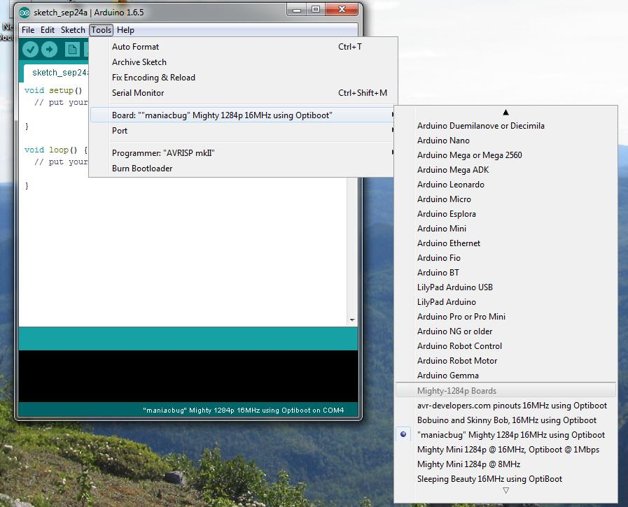

Figure 35: Microcontroller Selection

### **Programming Port Allocation**

Select the FTDI Programming COM Port: Usually Com 4

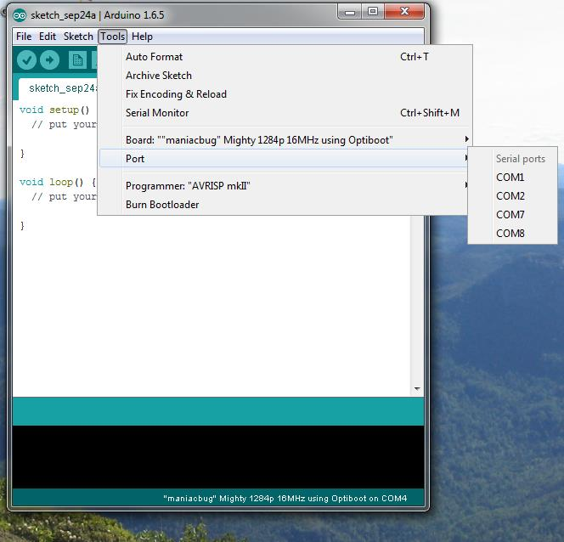

Figure 36: Programming Port Allocation

### **Ludlum 2000 Rate Meter Program files**

Open the Ludlum 2000 rate Meter program by selecting File Tap and open

Click on the button: Verify

The ArduinoTM programming environment will compile the program.

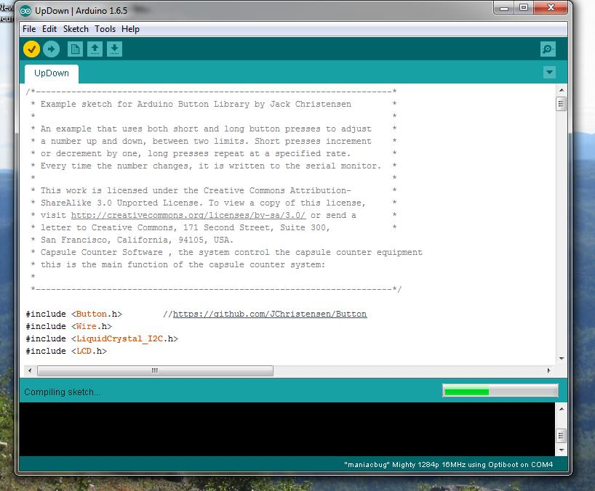

Figure 37: Ludlum 2000 Rate Meter Program files

The ArduinoTM programming environment will display the following message if the program compilation occurs without problem

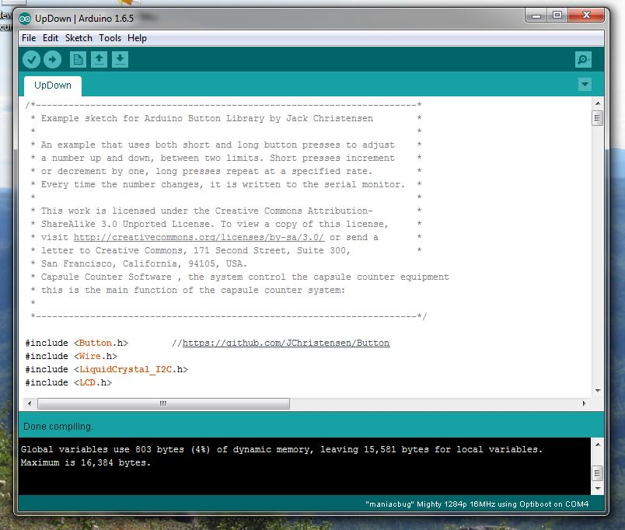

Figure 38: ArduinoTM programming environment Compilation

## **Ludlum 2000 Rate meter specification**

Specifications:

* Voltage:                              Single Phase.
* Nominal current 1Amp

Electrical panel assembled by:

|  |  |  |
| --- | --- | --- |
| Name of the electrical technician |  | Date |
|  |  |  |

Electrical panel verified by:

|  |  |  |
| --- | --- | --- |
| Name of the inspector |  | Date |
|  |  |  |

Final approbation by the Group Leader, Software development

|  |  |  |
| --- | --- | --- |
| Name of the group leader |  | Date |
|  |  |  |